

From one server install - and start all the three servere

# ansible master ka through connect kart hai teno se ssh ka througj

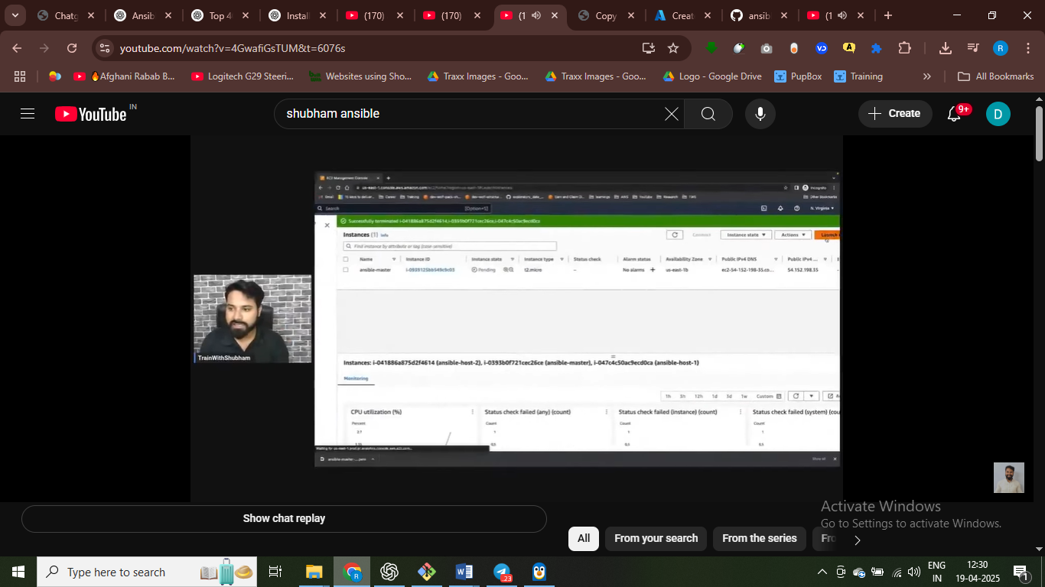

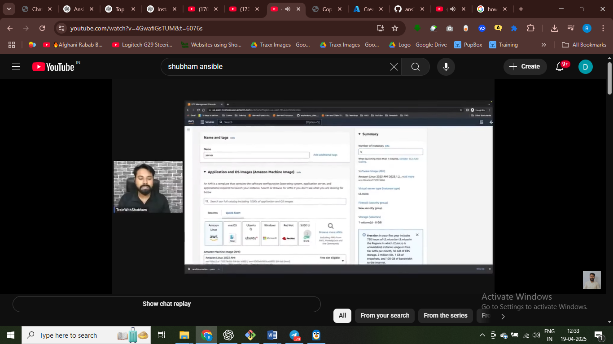

Same key pair as used in master node

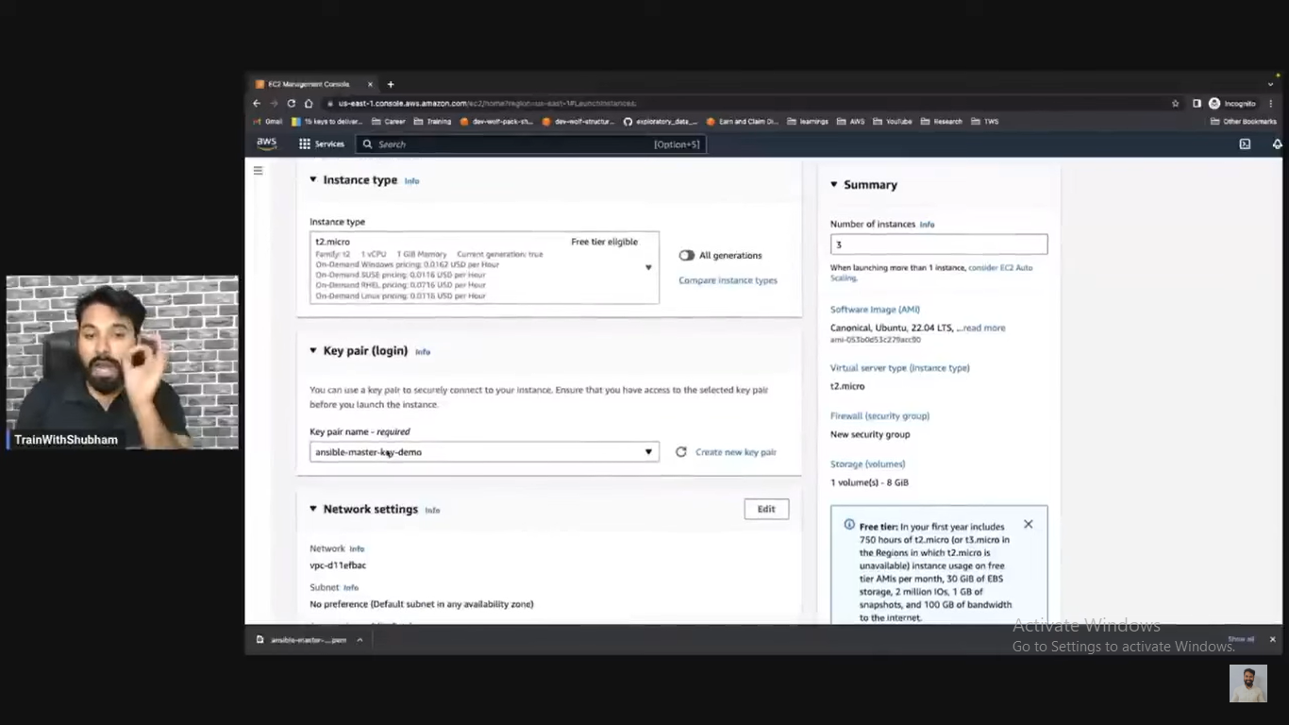

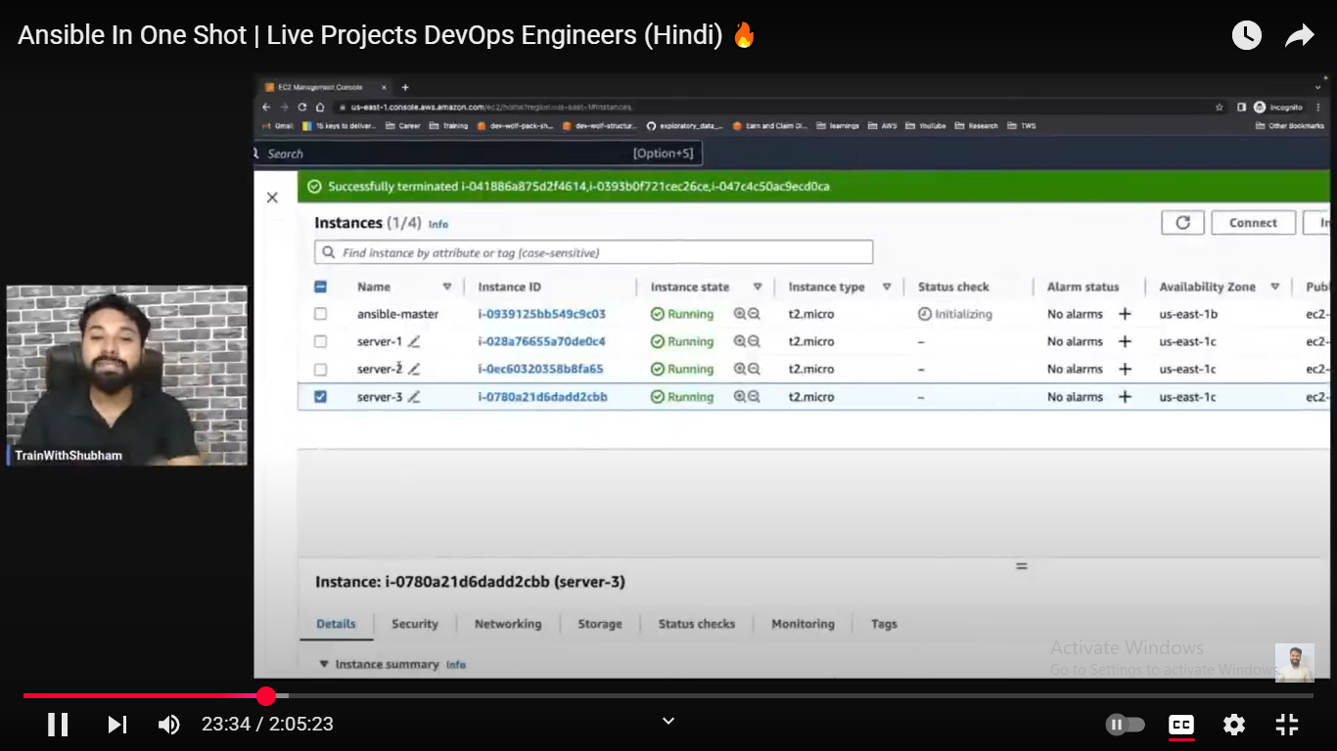

Ansbible update all the servere

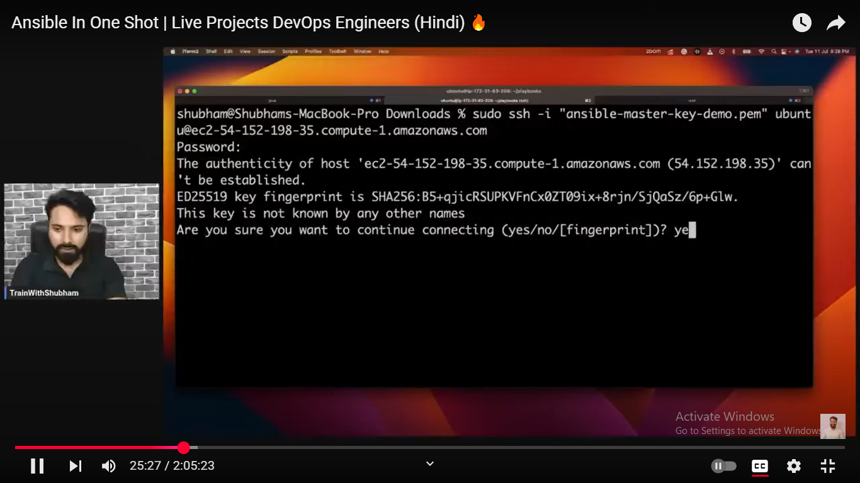

#login into ansible masger

Install ansoble On VM

sudo apt-addrepository ppa:ansible/ansible

sudo apt update

sudo apt install ansible

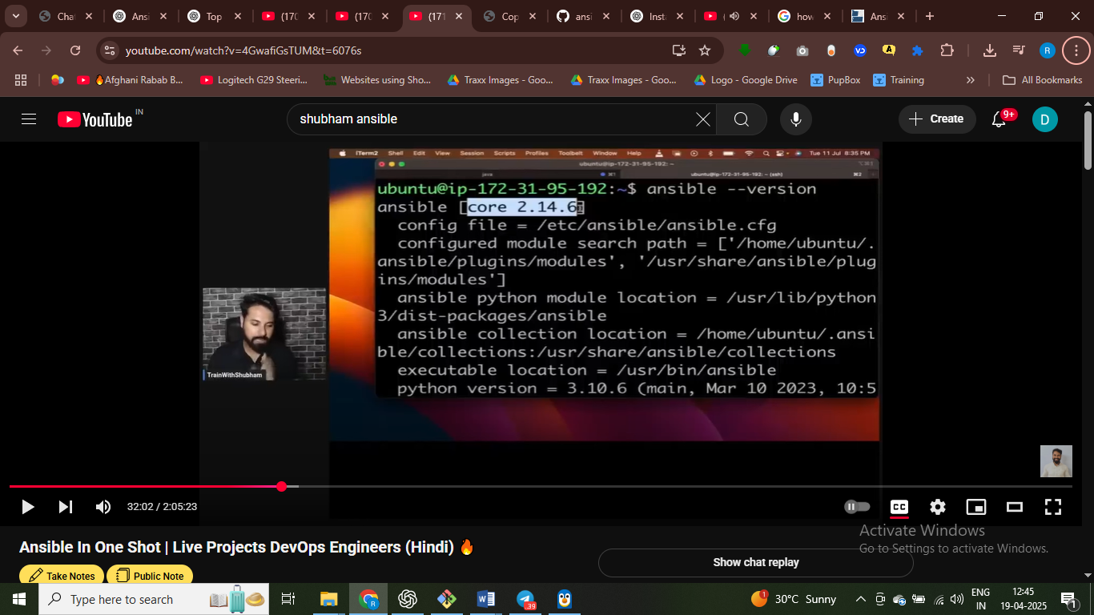

Update the host file after install ansible

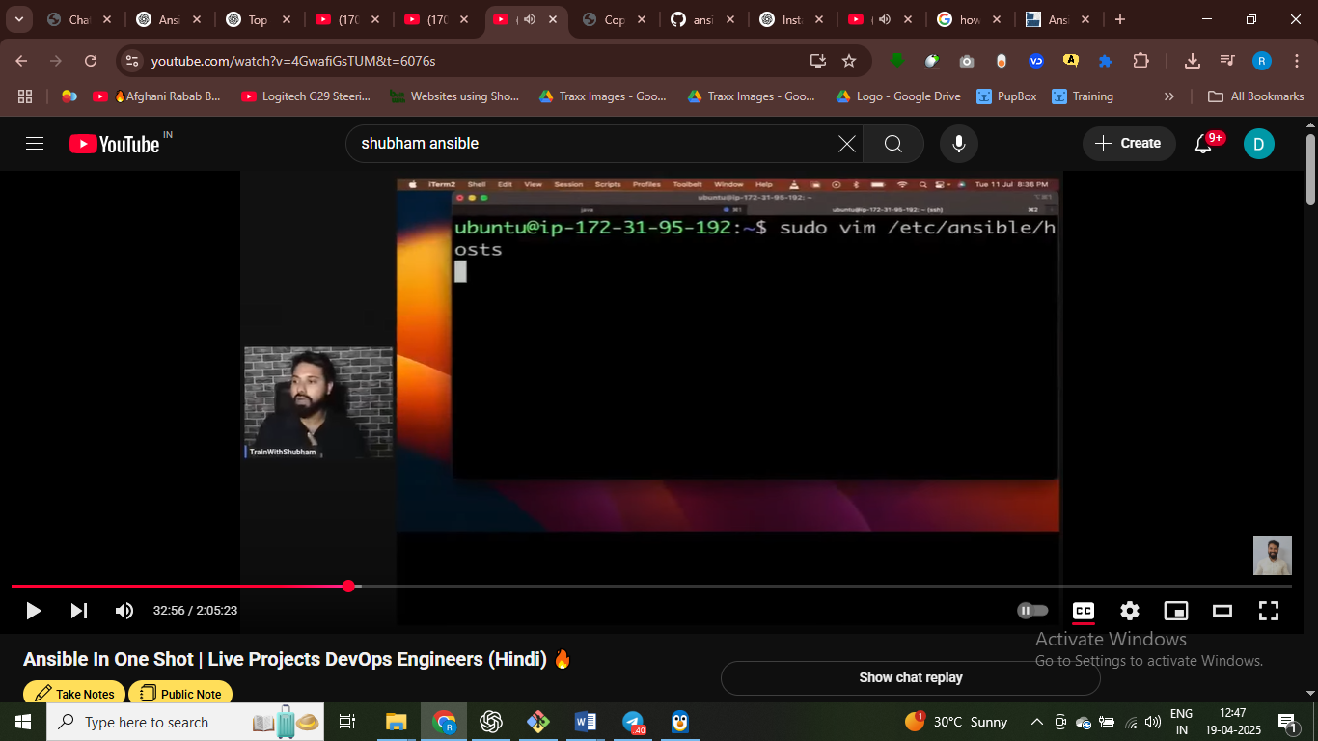

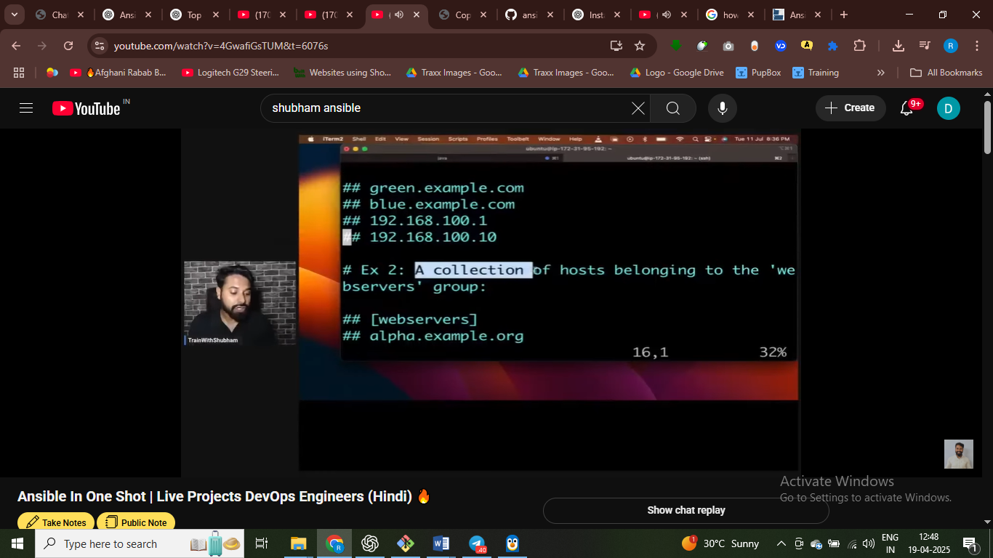

# ip address dalte hai – host file main

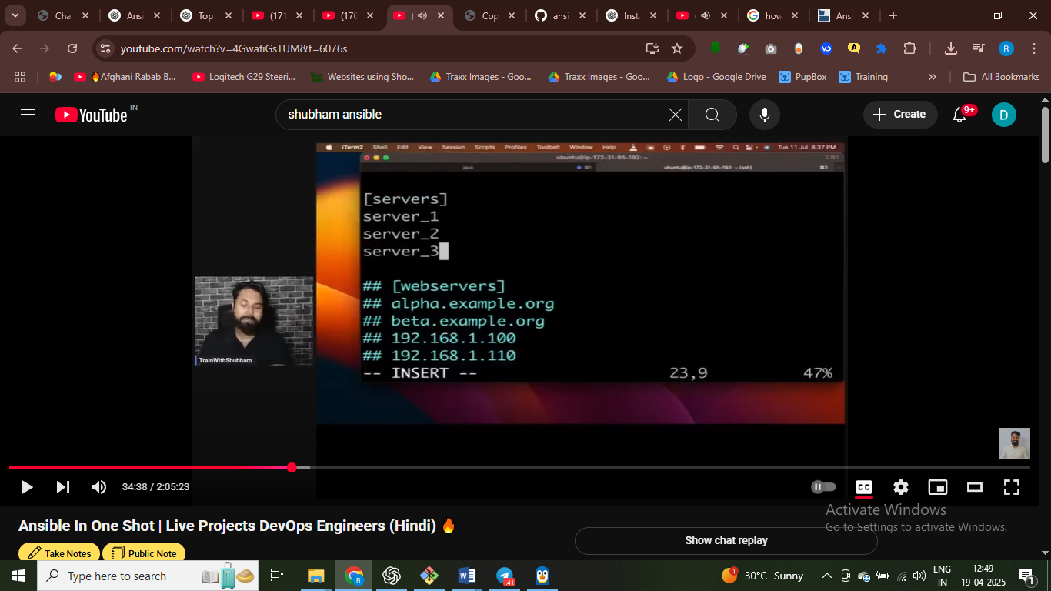

Server ka group bana diya

Ek varibal to hole ip address of server – ansible_host

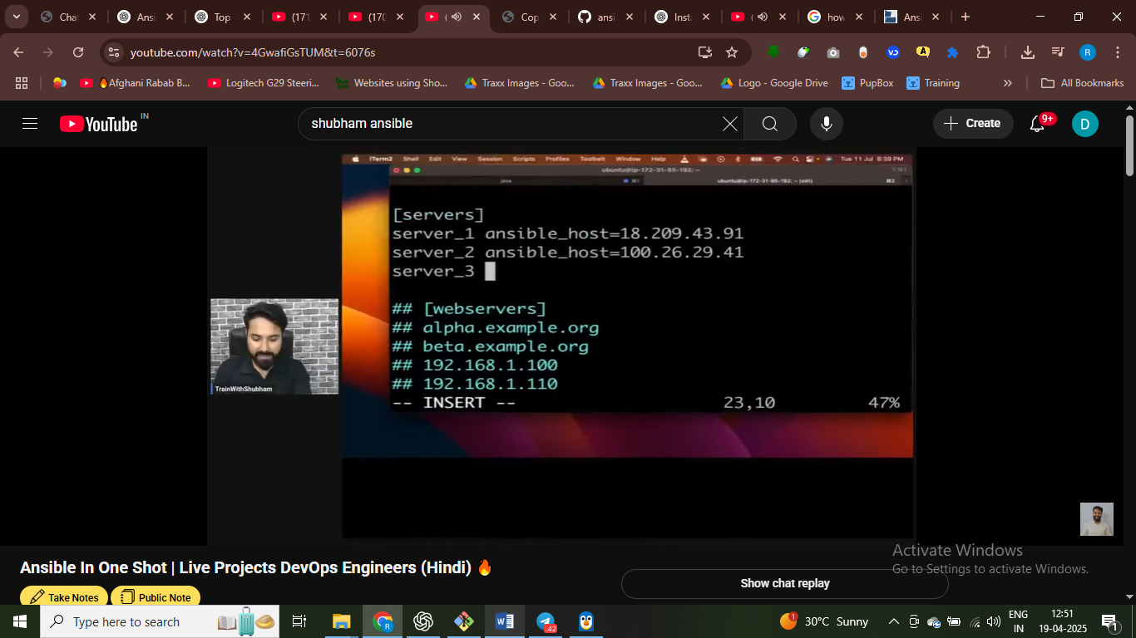

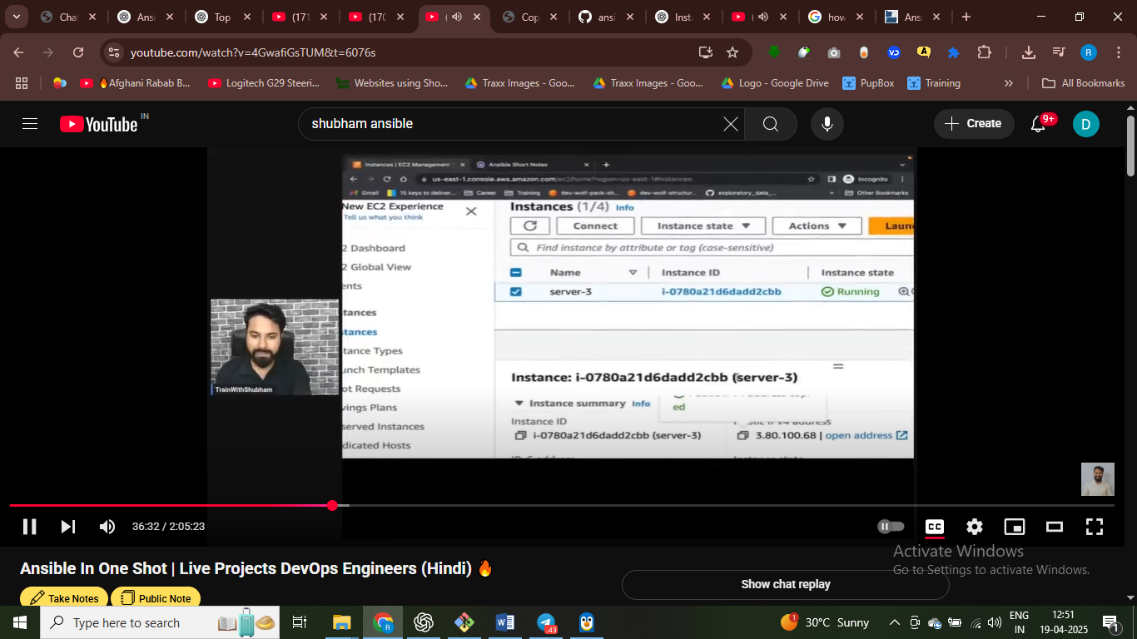

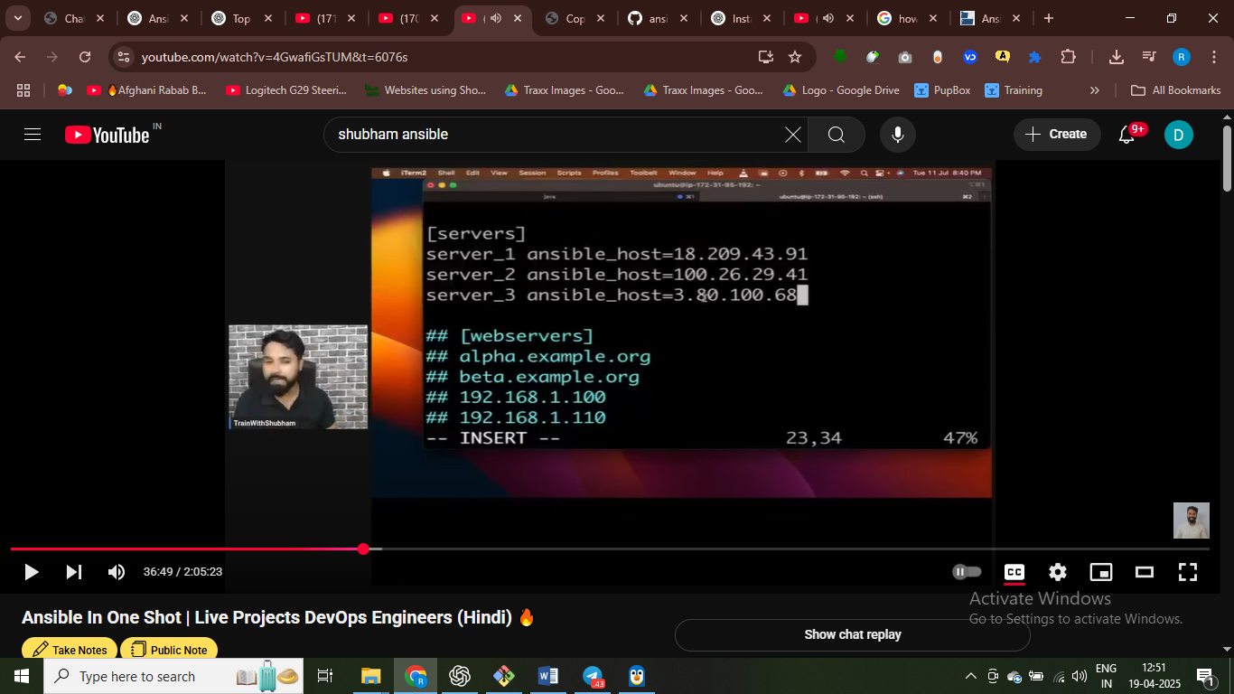

# ansible ki host file main – we can group the computers that we want to connect

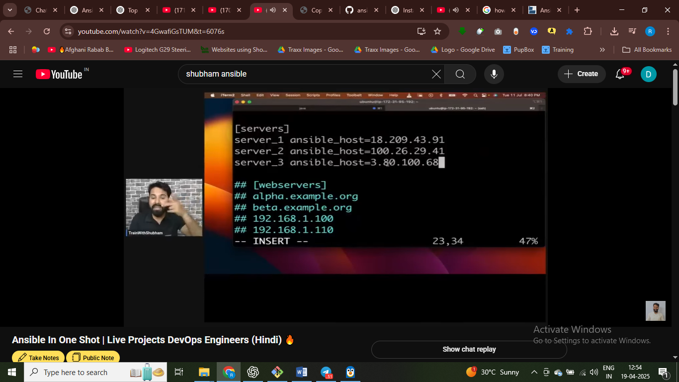

Host file contain all the server details that we waanna connect

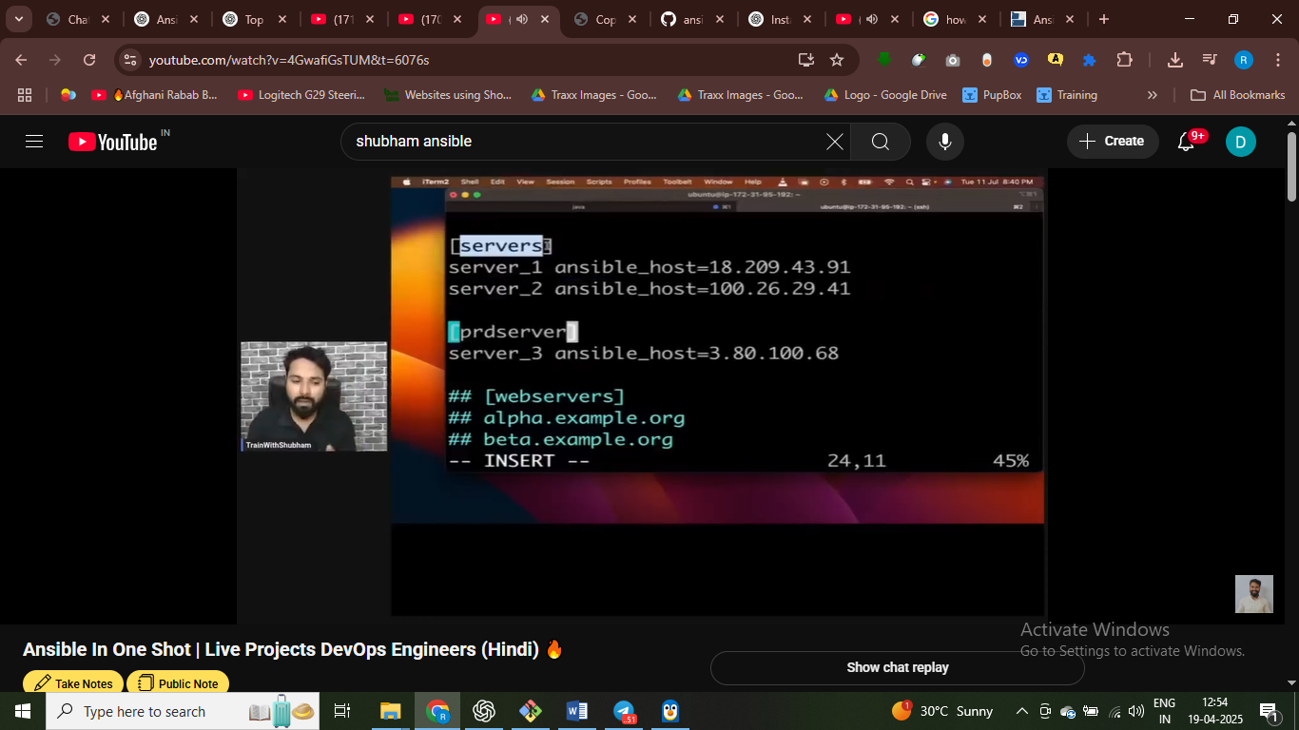

This is way to write host fiels

4 server ko magnae karna toh unki public ip hame – host file main dalni hai ip address sabhi serve ka shat

# host file ko connect karna toh hame master main – toh hame private key chaiye

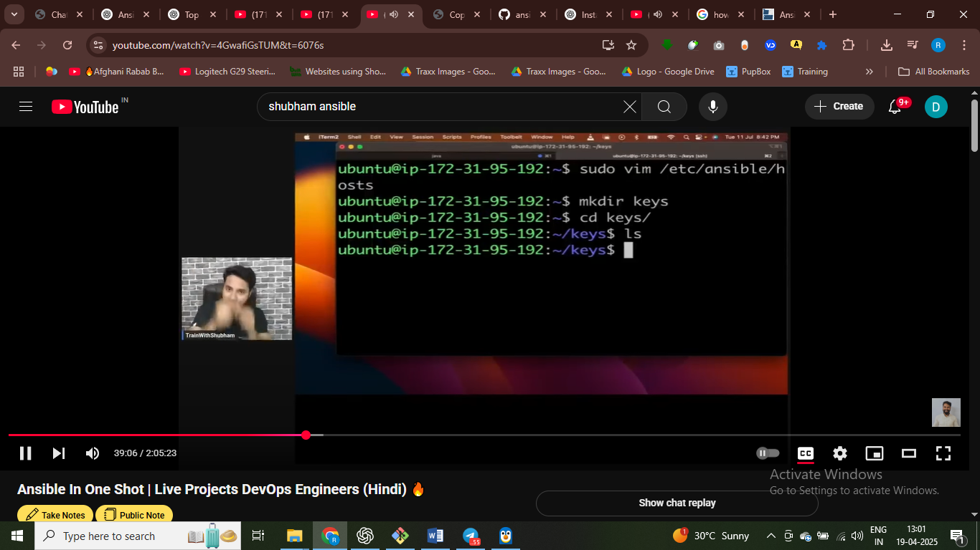

# master main private key dalnege = jisse baki server ko connec t karna hia

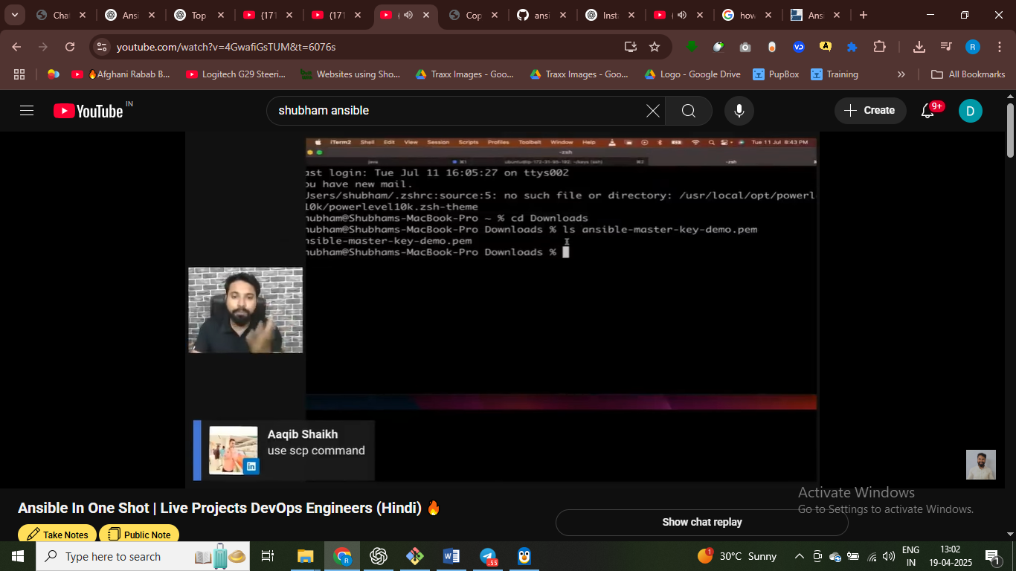

# local se iss file ko server pa phochan ahai

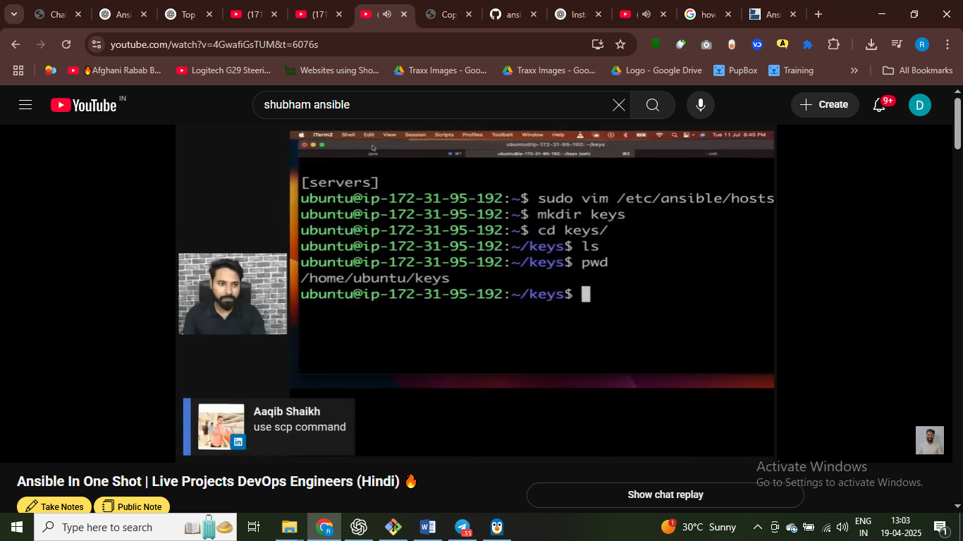

Ssh cmd ko copy karo aur isme thoda se chang kar doo

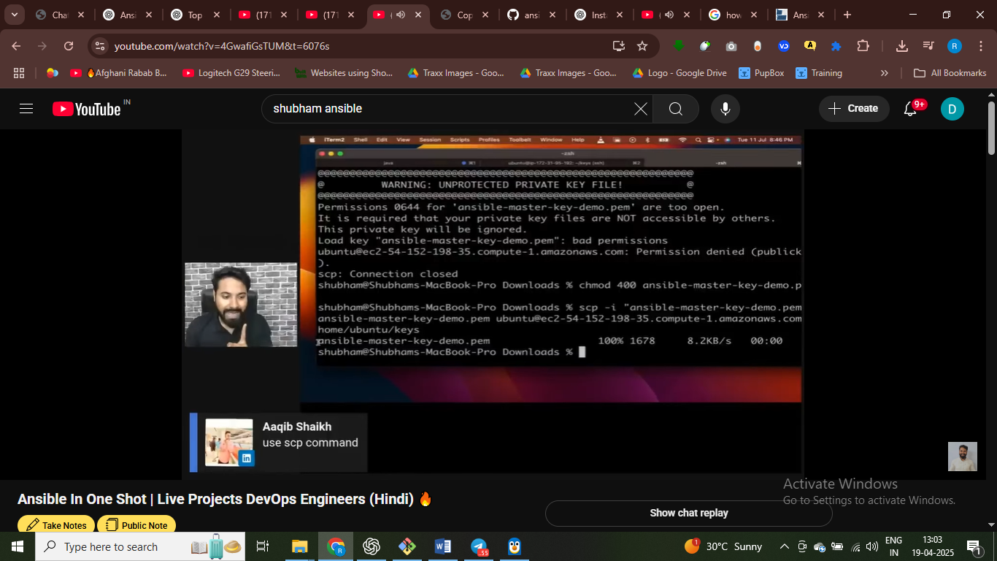 scp –i “file name .pem” destination :/home/Ubuntu/keys= copy in this directory

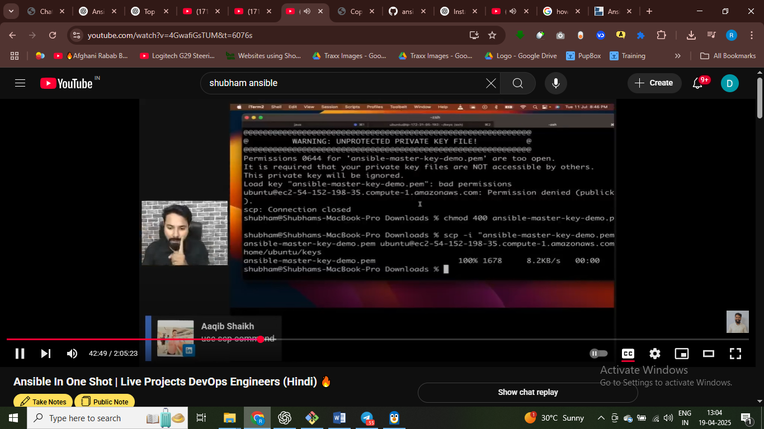

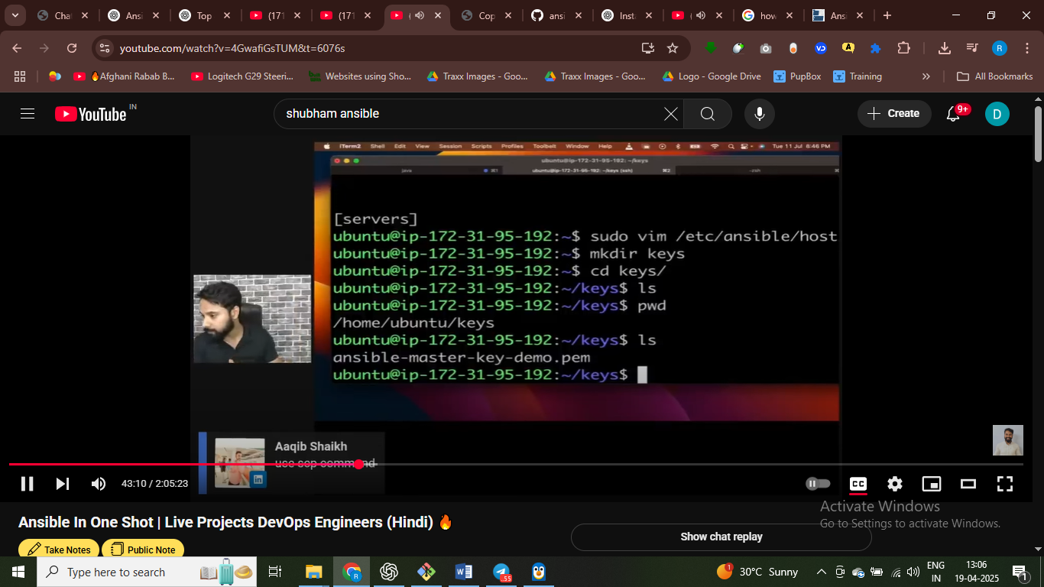scp similar to shh

Ssh ka liye key chaiye nthi

Updating host file – so that we can connect to this file and

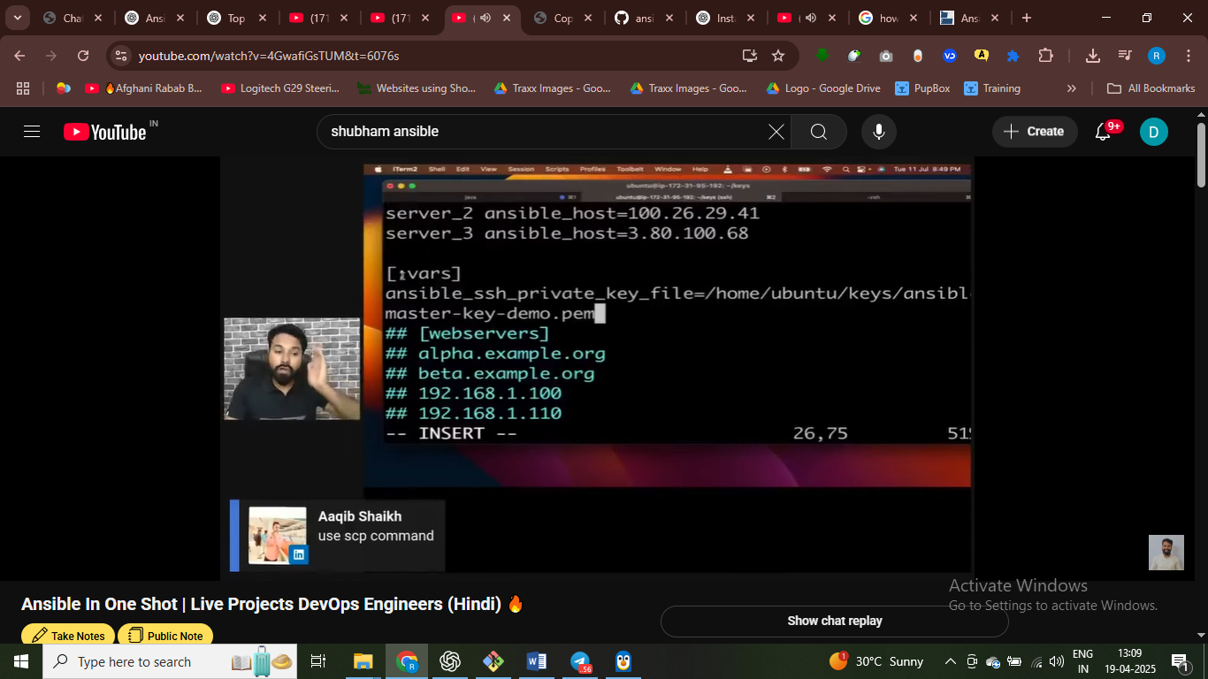

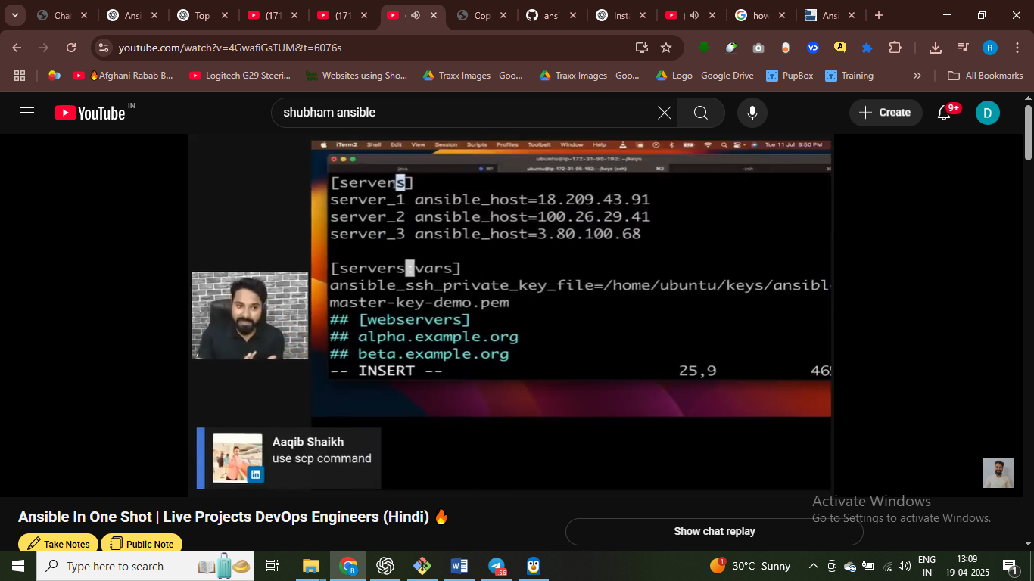

# sabhi serveers ko private file ye wali milegi

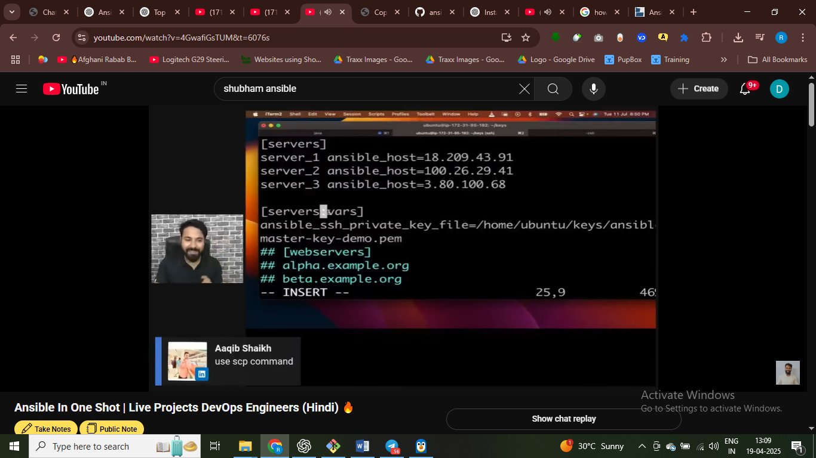

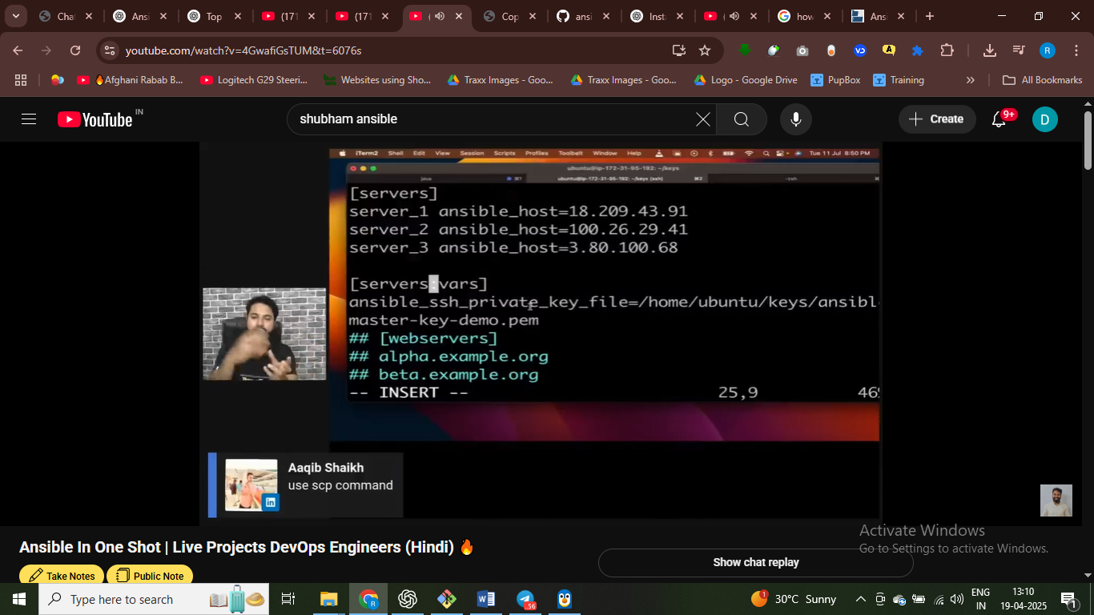

# sare sersver ko ye private file access ho jayegi

Iske use karke sabhi server ko access kar skate hai

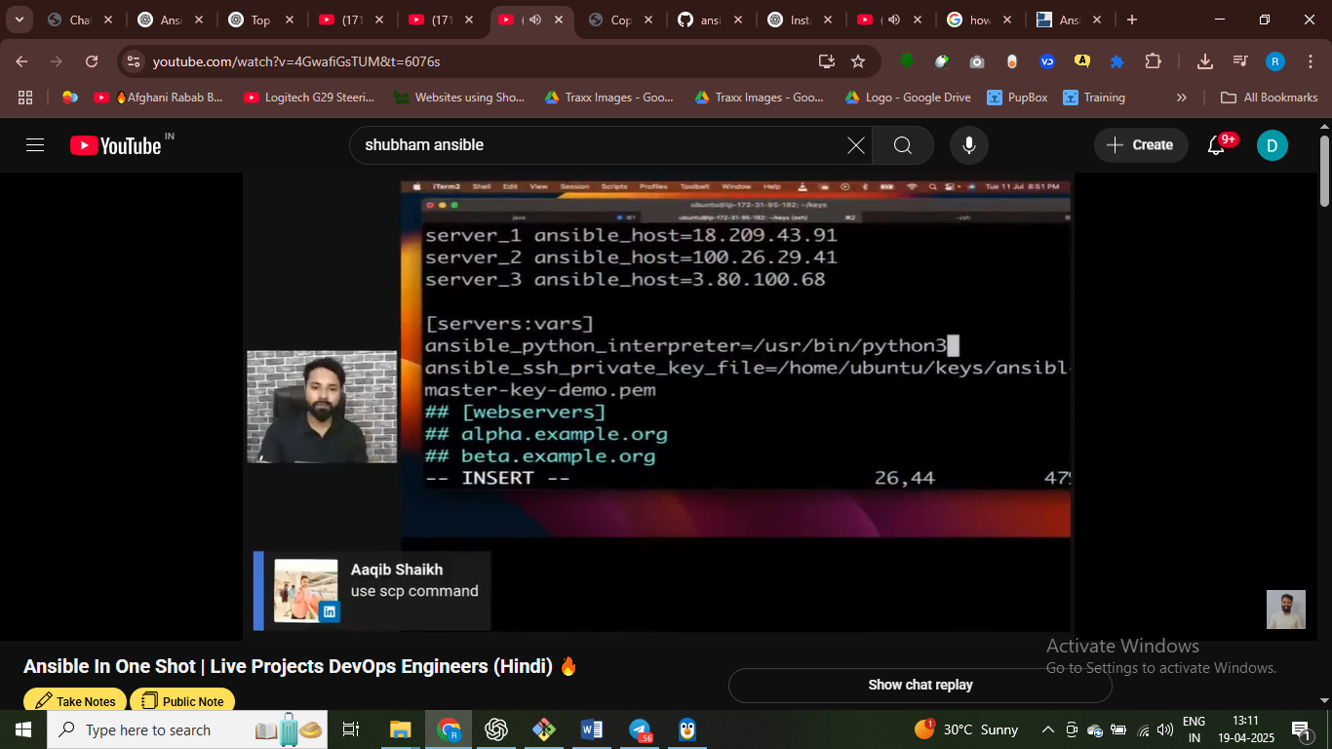

Har server ka pass python interpreted ye wlaa hoga

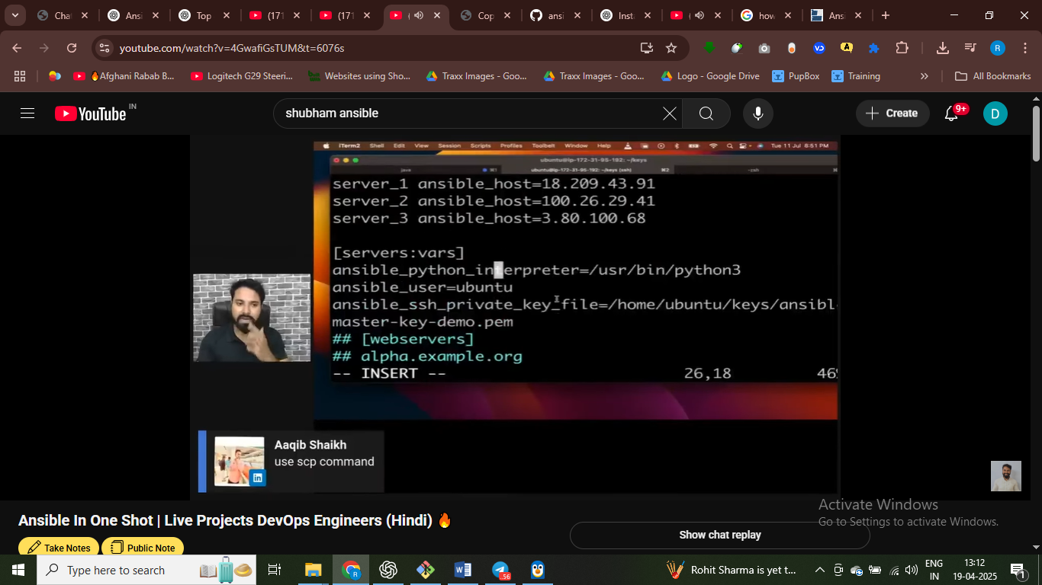

# server ka group banaye aur usme varibel daal diye

# host file =- jitne bhi server harmara pass hai – un sab server ko kasie connect kar rha ahi

Host ka address janke ip address – phir ssh – key hamne dedi

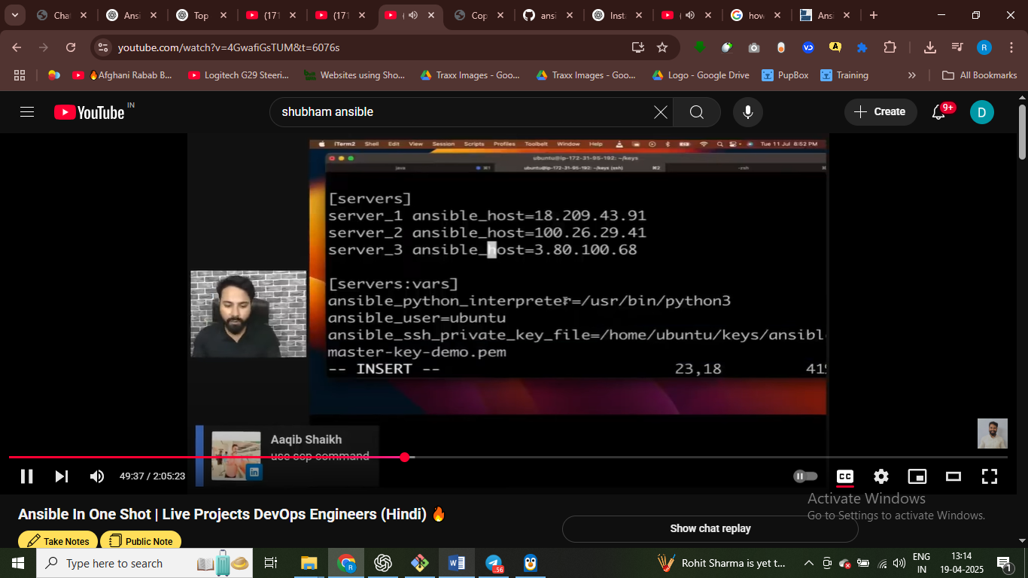

Cmd main – adhoc aur modules hote hai

Adhoc cmd jaise jo shell main likhte hai – jaise clear pwd df –h mkdir

**Module aise keyword** jiske andar funcitonalty already build hoti hai



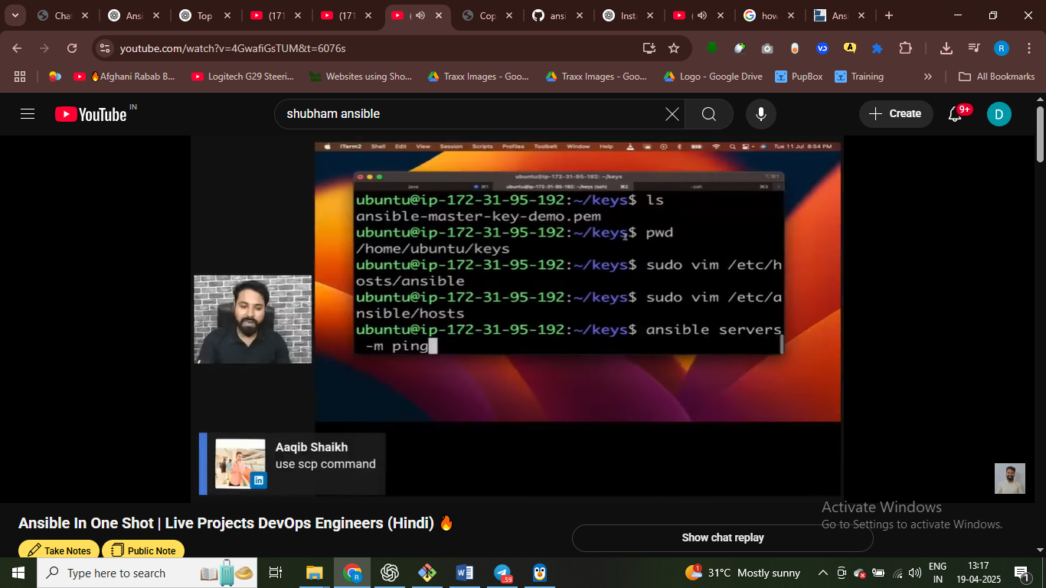sare server ko ping ho pyagea

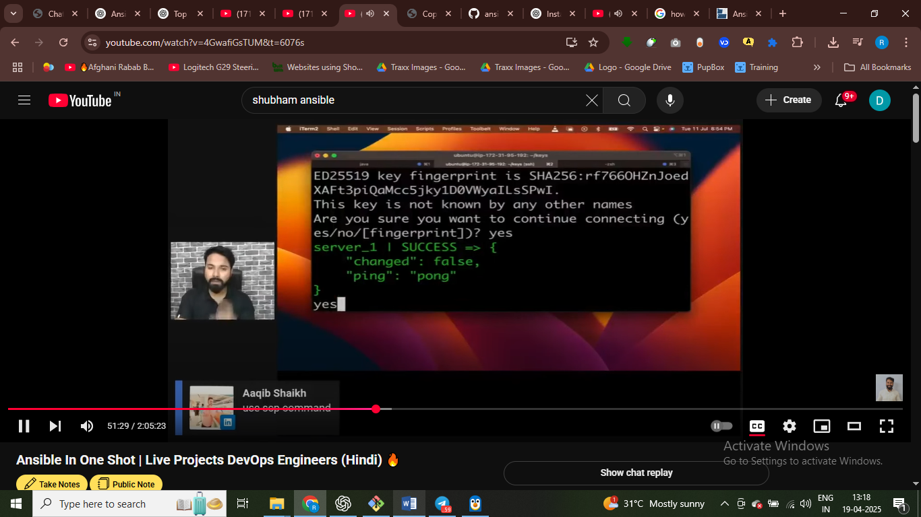

Ek master se teen server ko ping kar pa rha hai

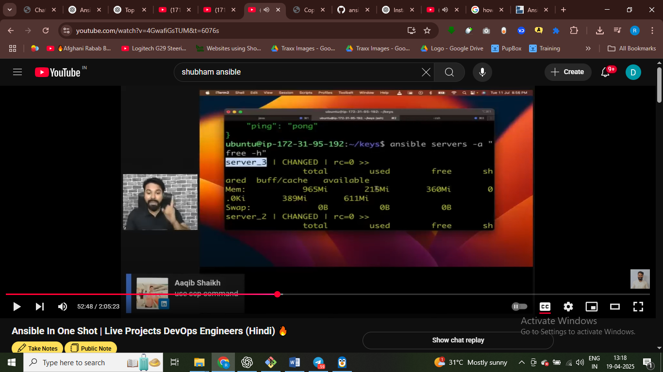

# sabhi sarever ki ram pata kar sakhta hai—free –h

Kisme kitni used hai - adhoc cmd use kar hai - servers is our group

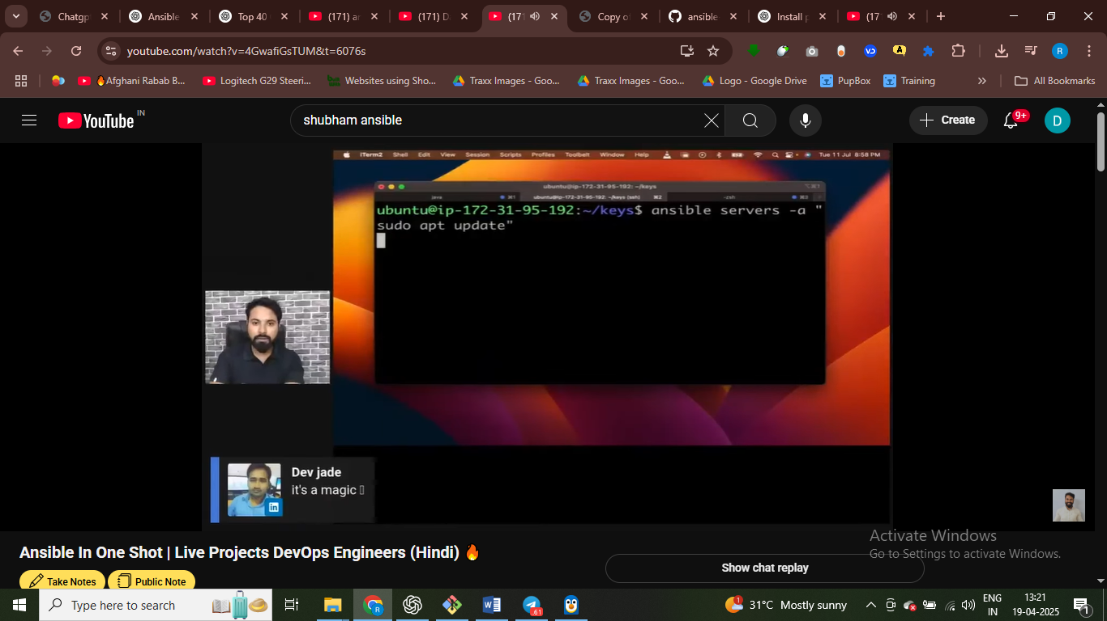

Update all the server using anssible – adhoc cmd

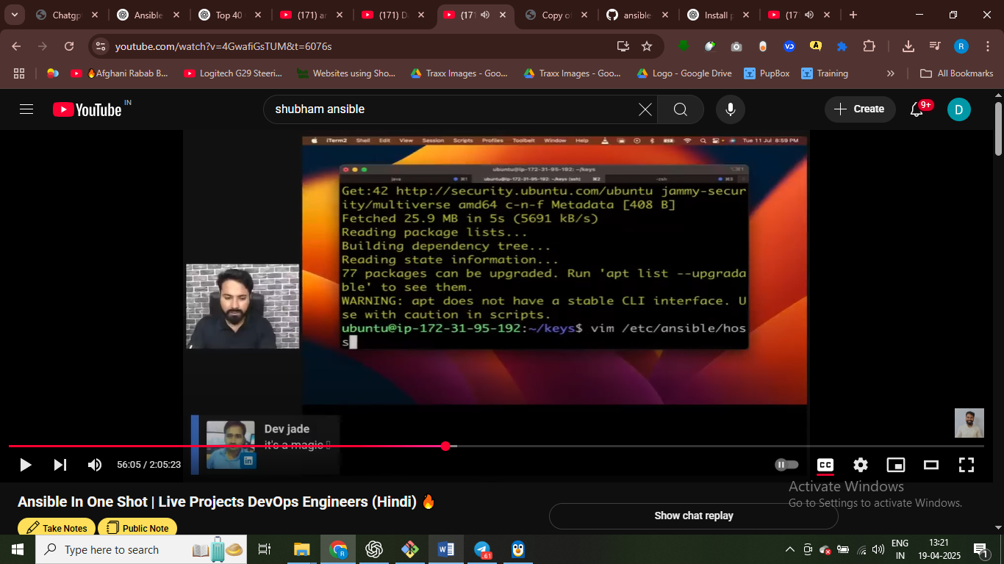

All means

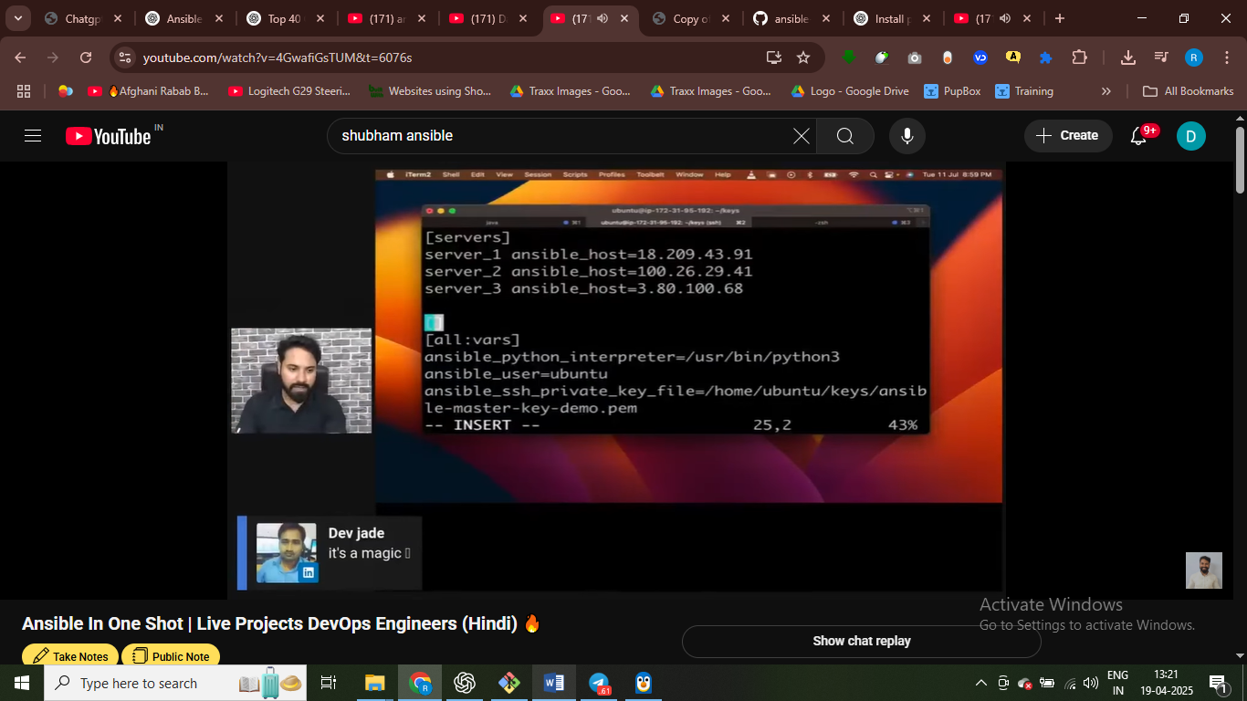

# sabhi server pa ye chij chali jaye

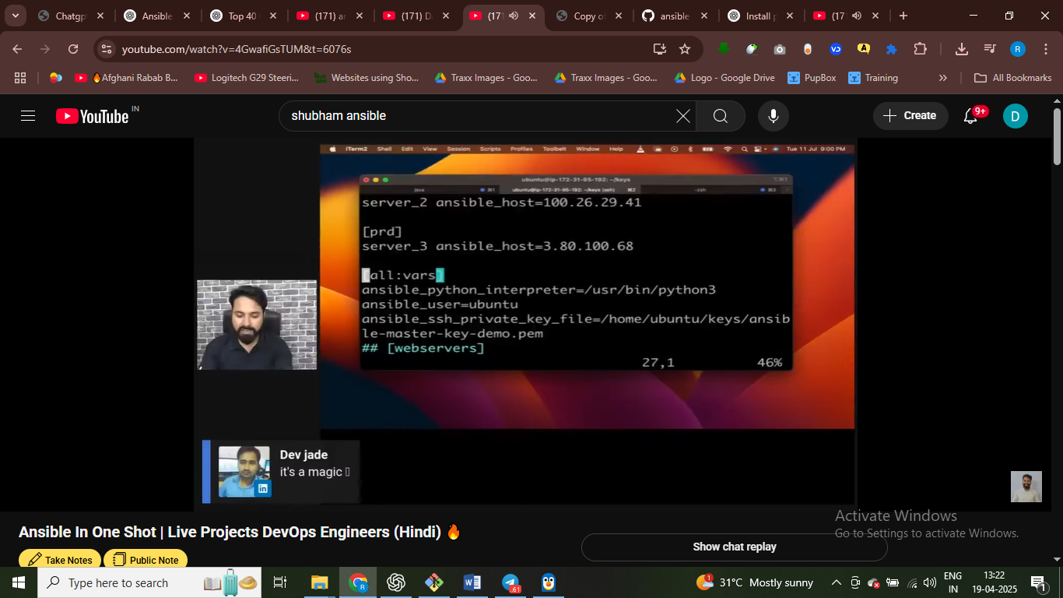





Ping only production server

Not reacheable due to server3 don’t have private key file with it



List all the server that w e have

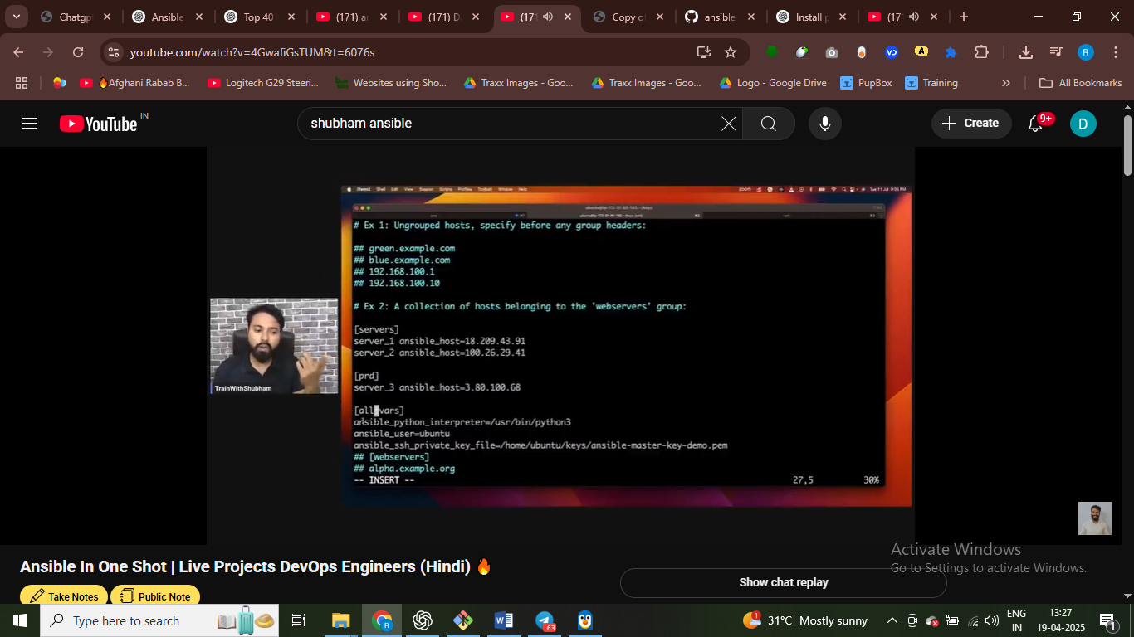

**All:vars – jitne** bhi group hai sabko access ho jaye hamra variable kaa



# if I ping the prodn server then it successfully gt ping



# play book amin task likhete hai

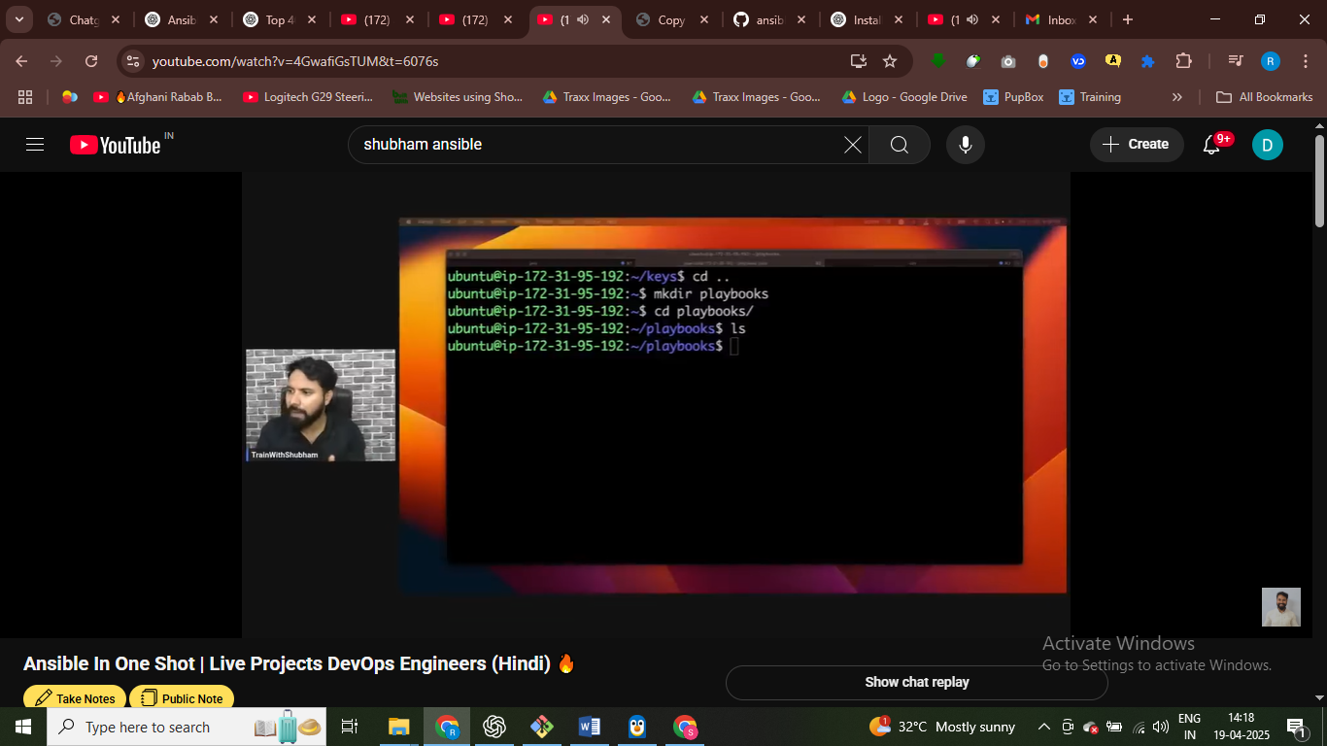





Iss playbook ko – servers gp main chalao –



Task ye perform karega ye playbook aur server wale group main chalgei ye playbook

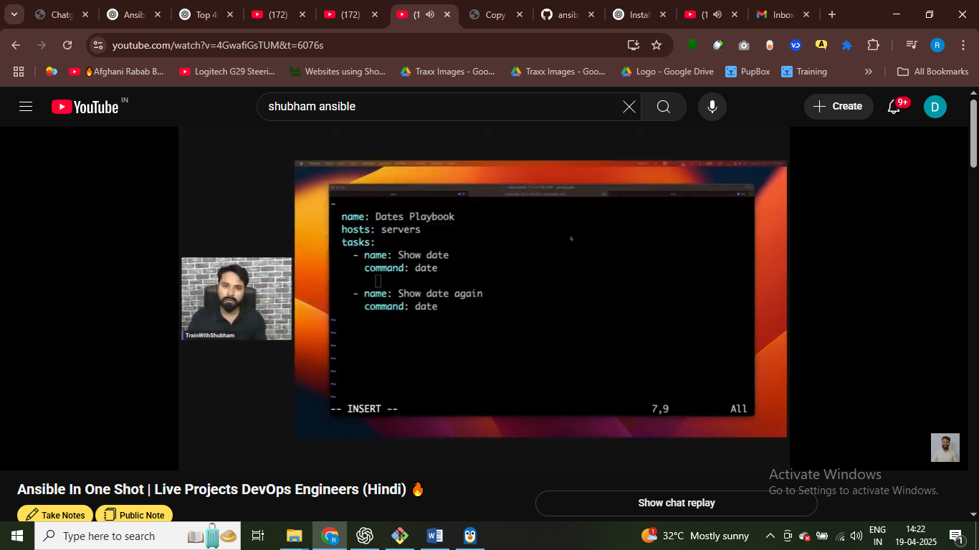:wq



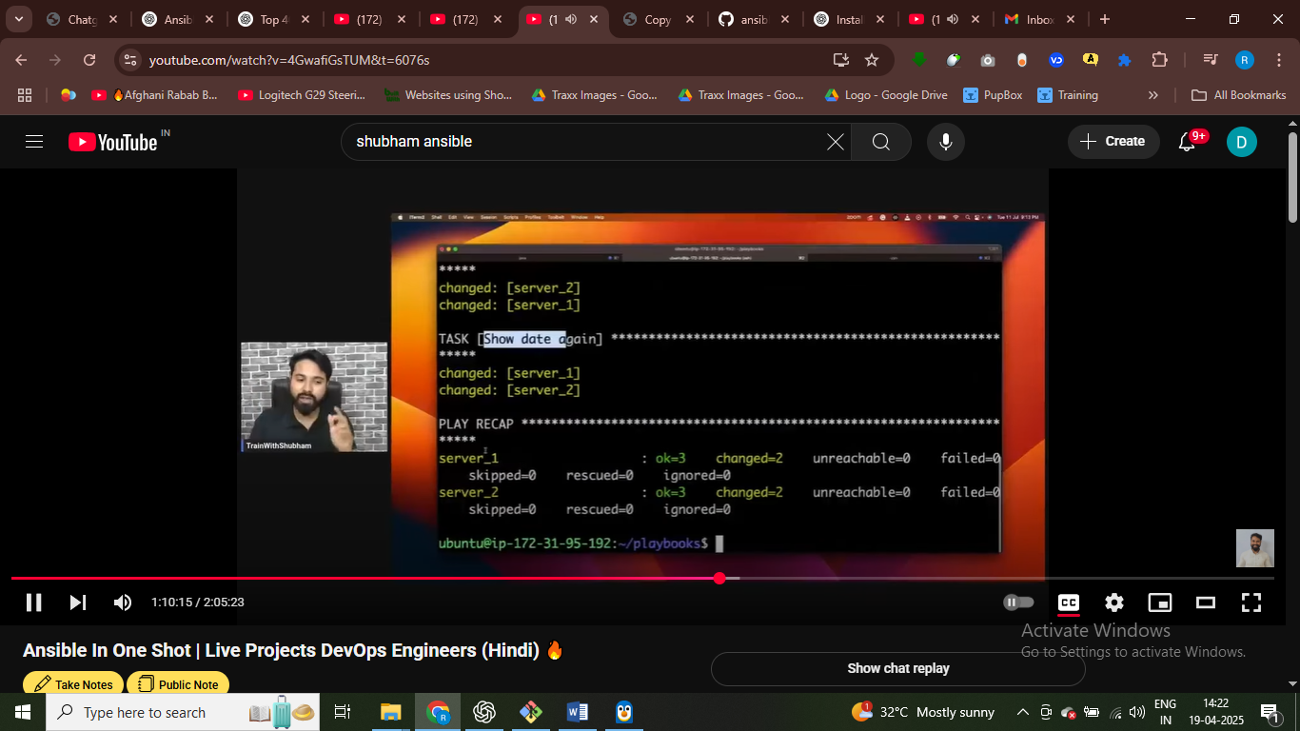

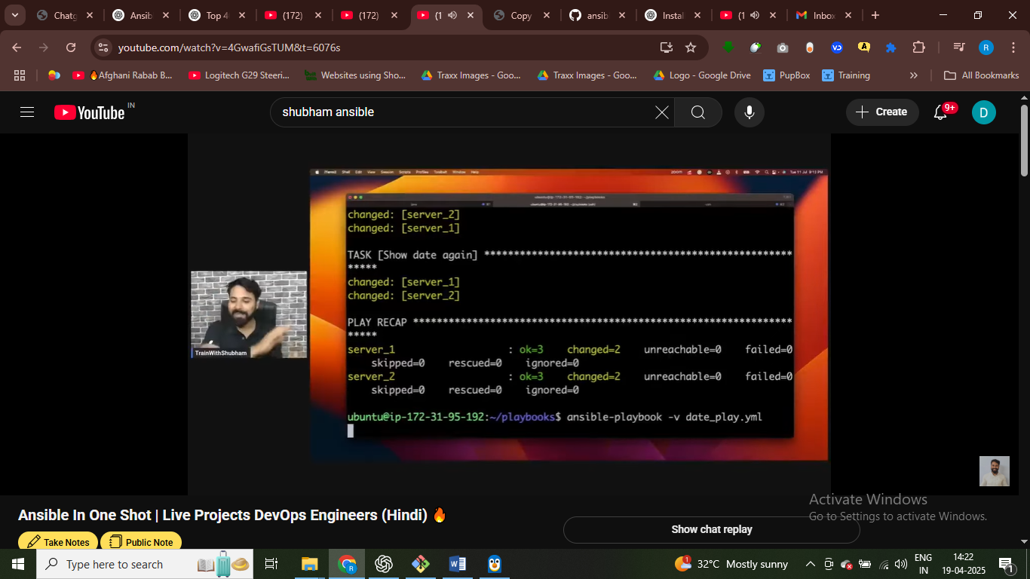

-v verbose for output of file

Task dene hai – aur hosts main ye playbook kha chalgi



Ye system kitni dar se chl rha hai

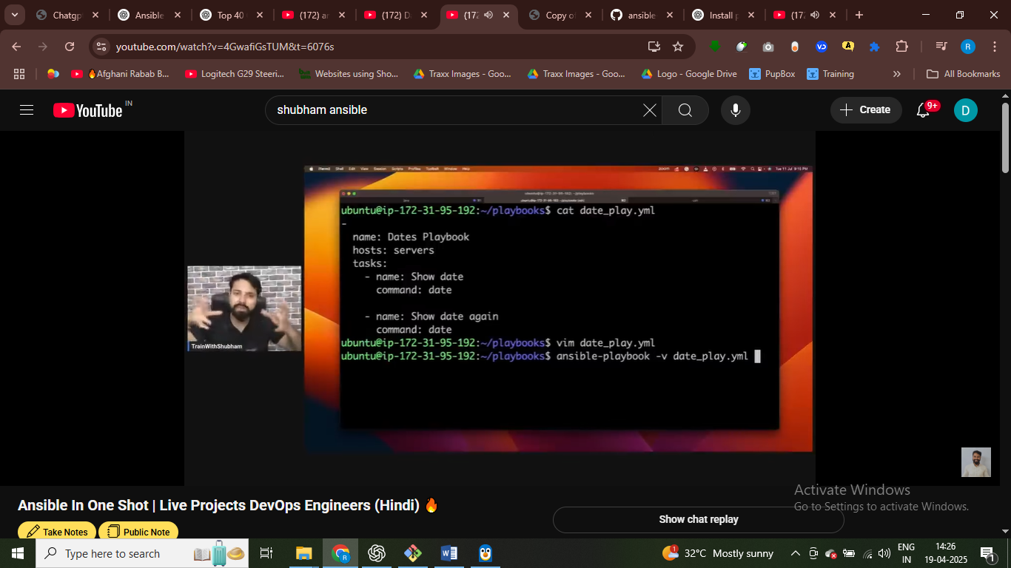vverbose output in human format



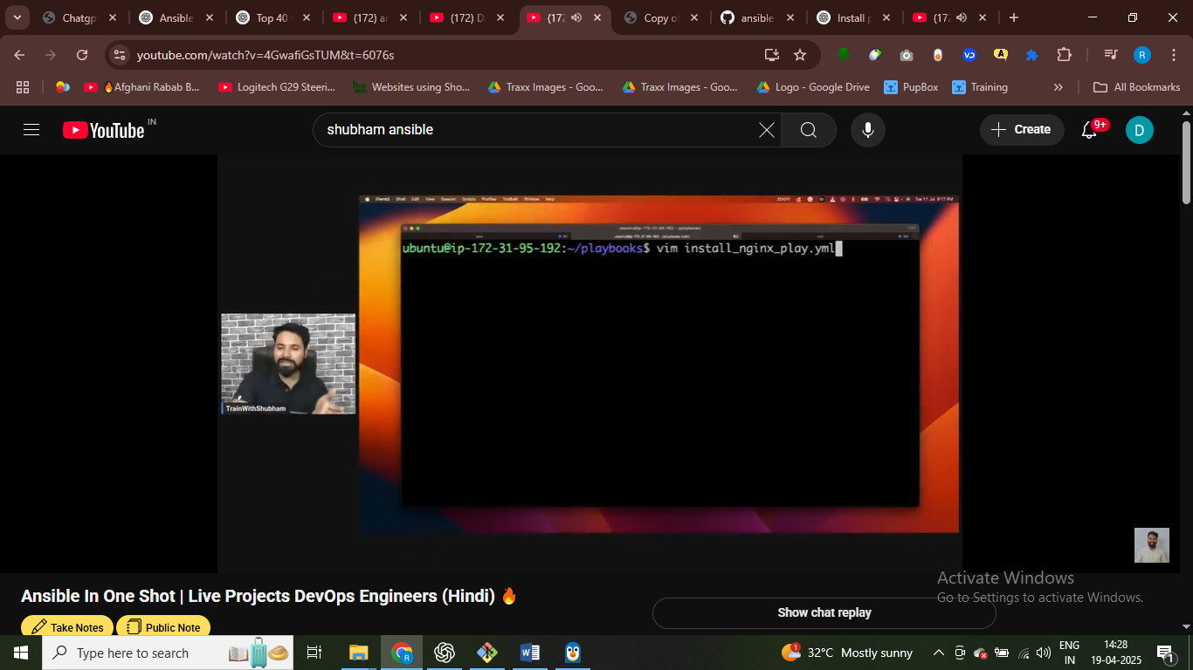

Write play book for install nginx



Run the script on servers – in hosts we are specifying here



Become true – so here we are becoming root user –

Run this script as user user

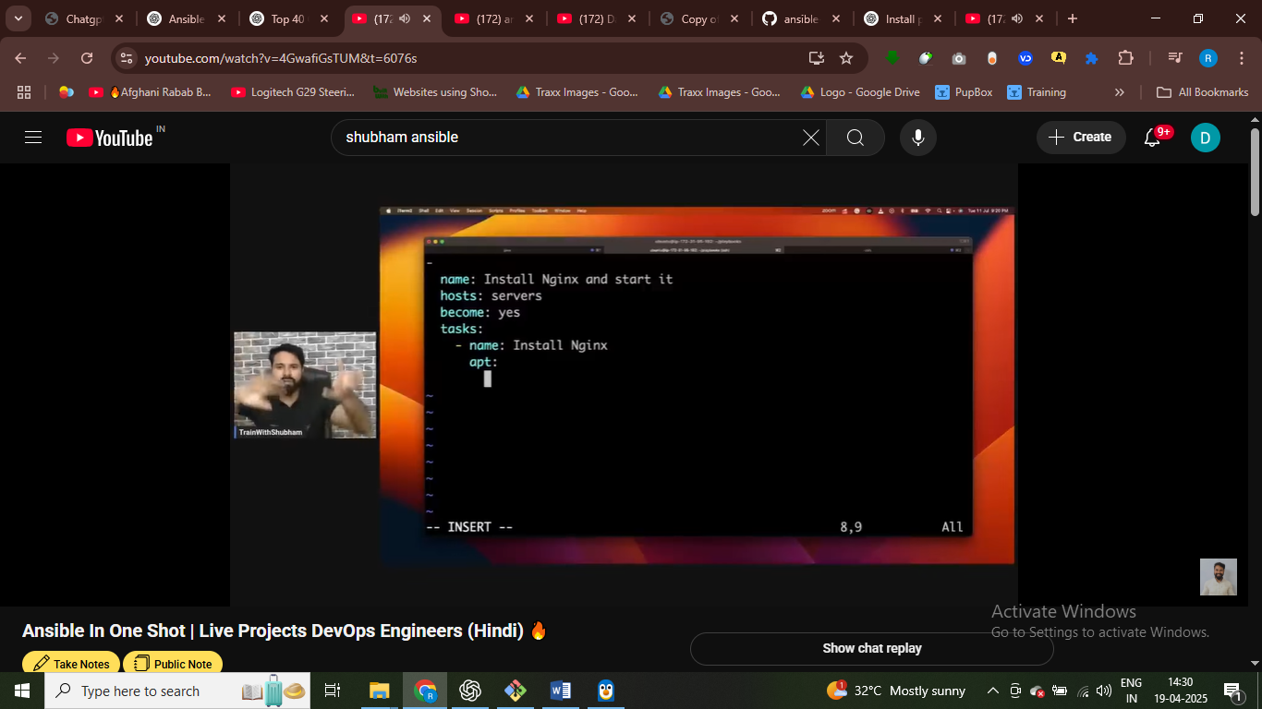

To install nginx we need to do it theroguh atp

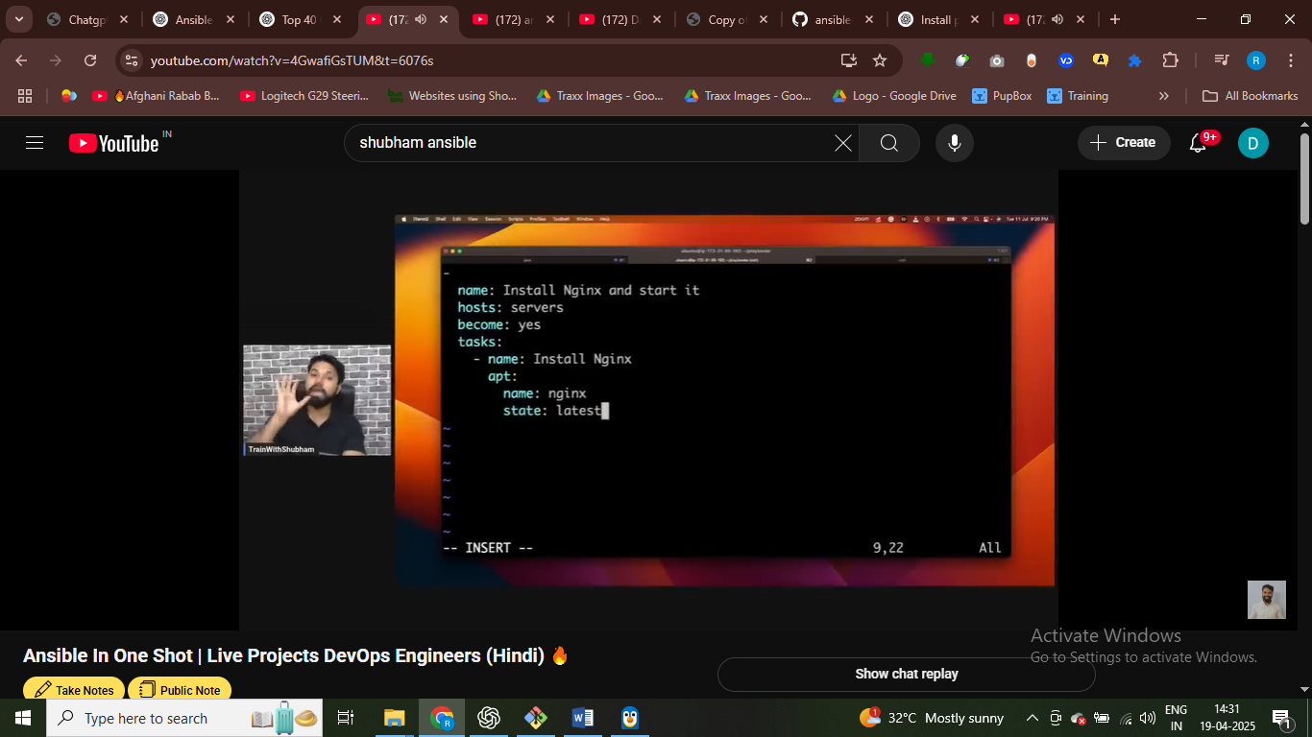state latest means latest version

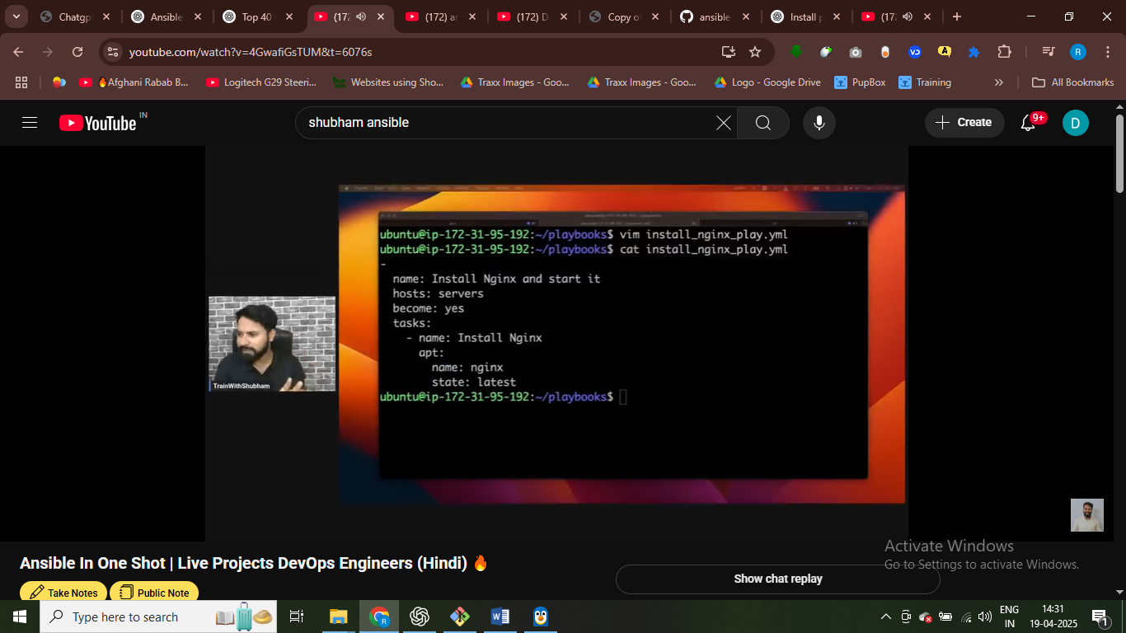

Apt package amagner used to install nginx = become yes to run as root users

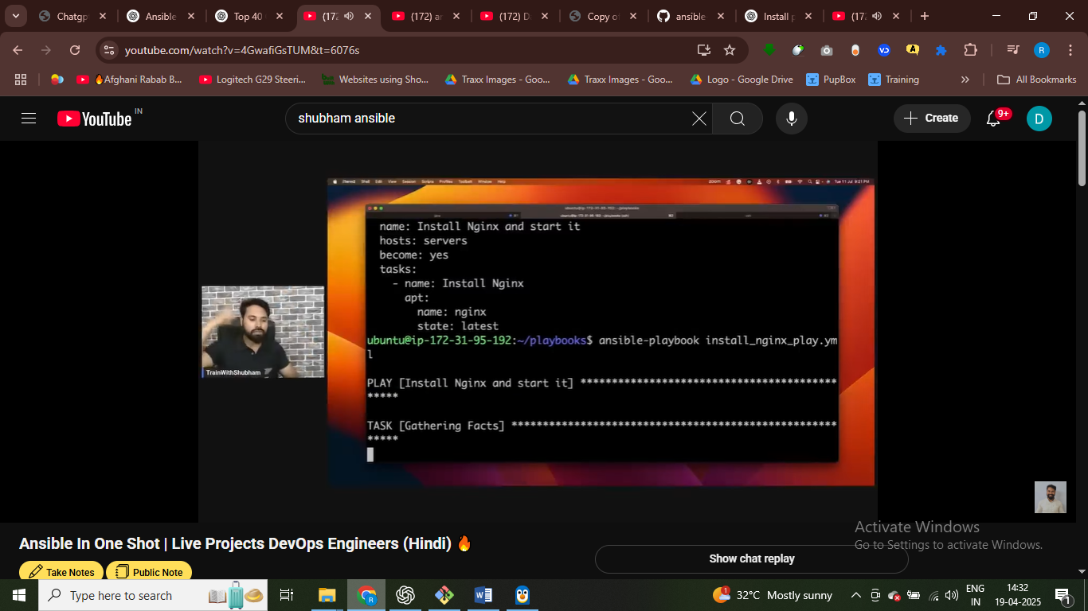

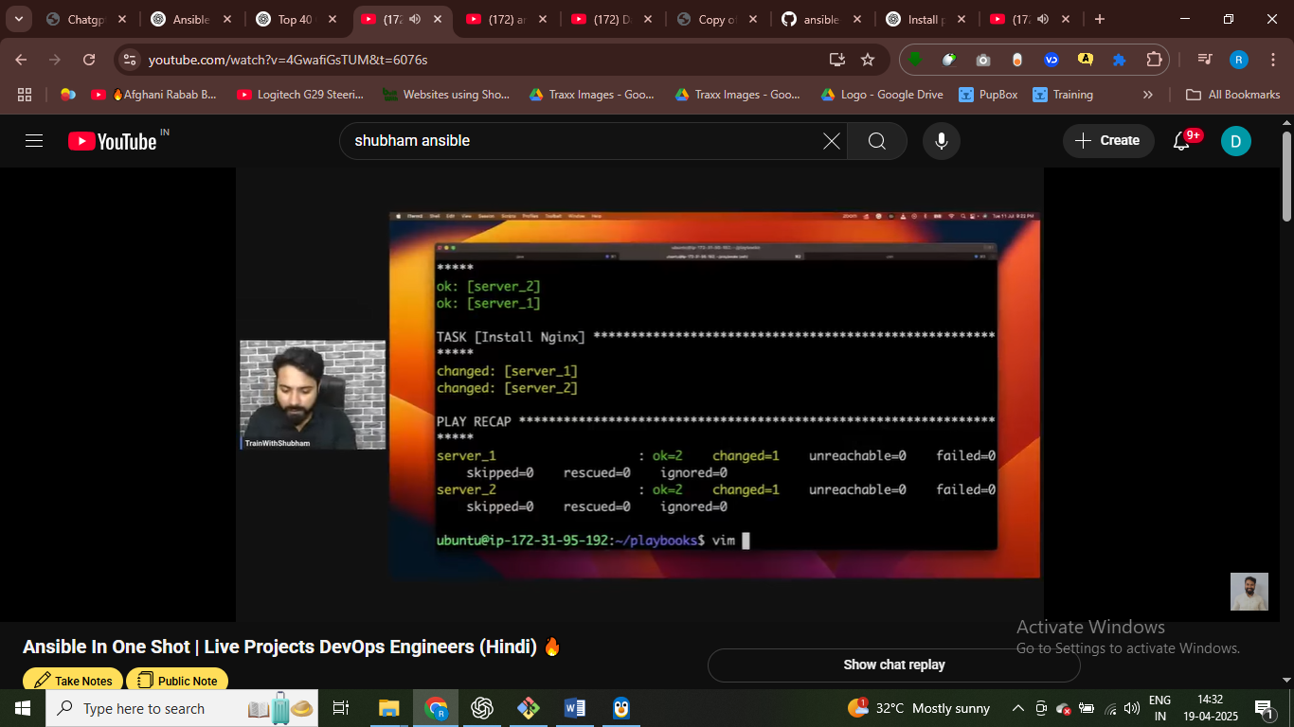

It showing changes means ngnixn installed on server

On servers – we have two server –in both server nginx has been installed

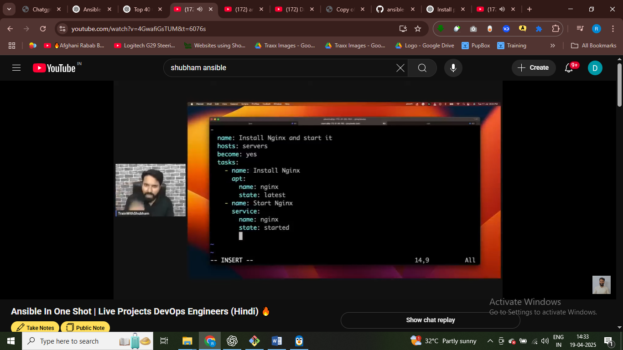

We need to start the nginx - so we need to use service nginx start

Statte- started to start the nginx

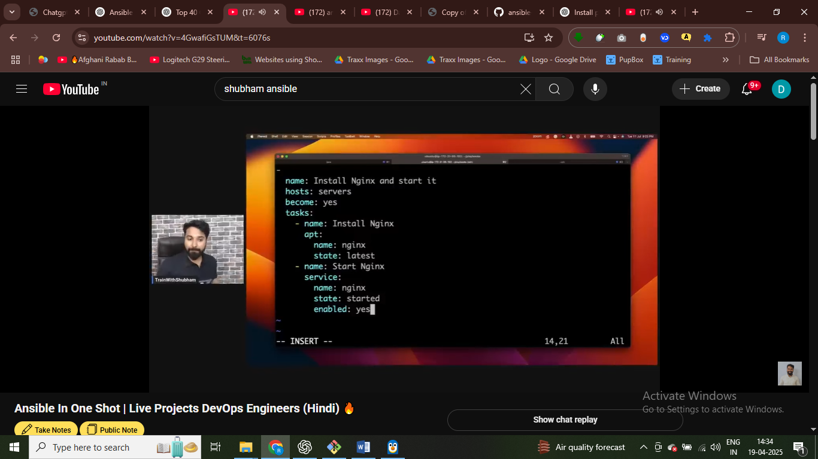

Enable nginx - on starting the computer nginx again started that enable

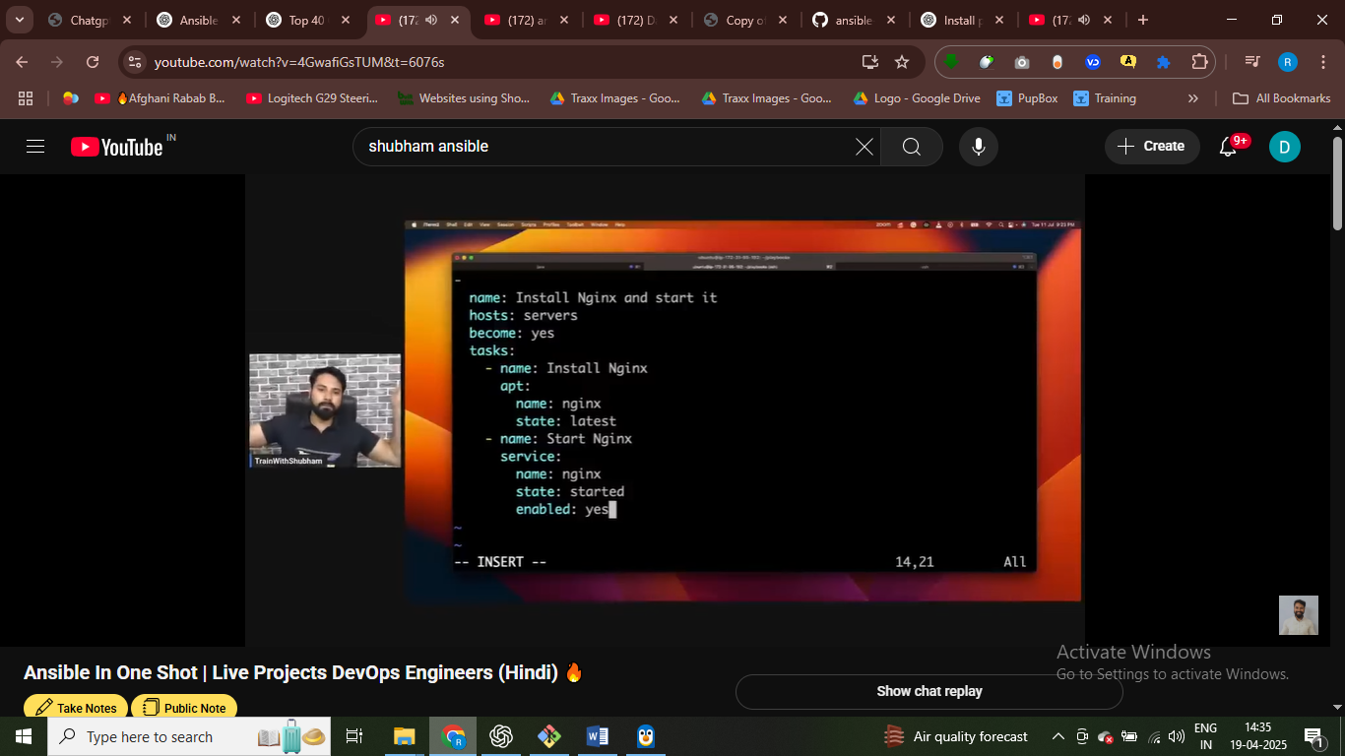

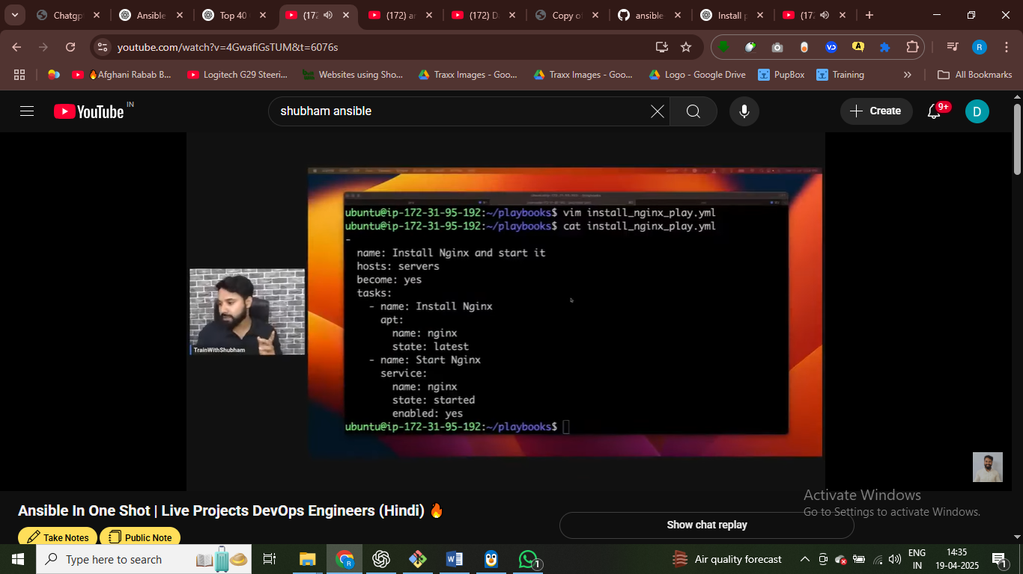

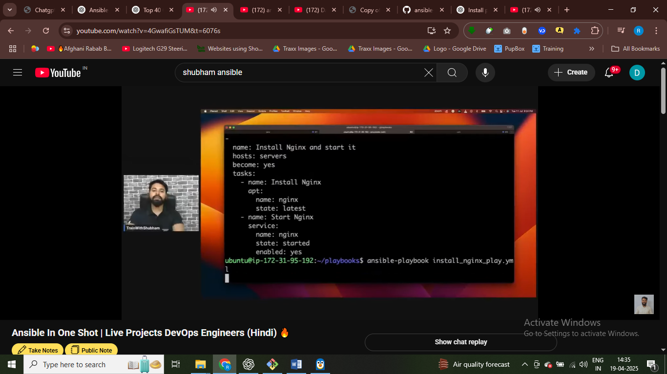



Server pa nginx chala dya hamne

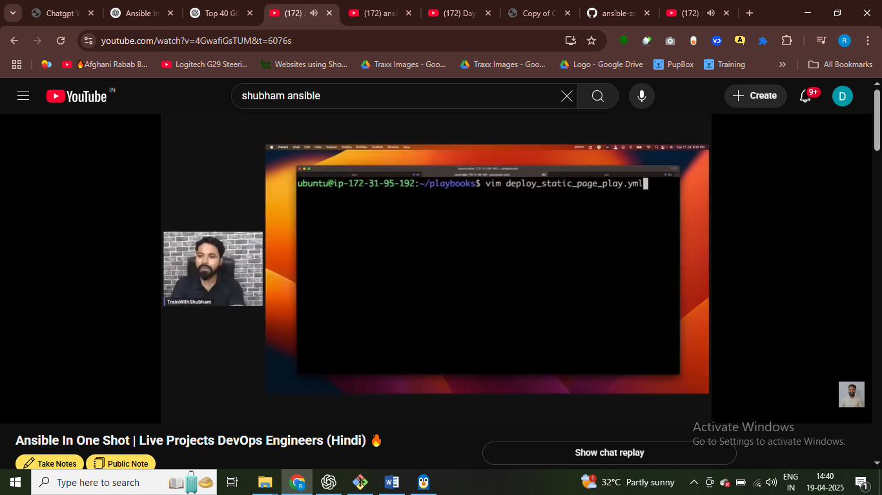nginx webpage install ho aur hamrai website ko live kar dee

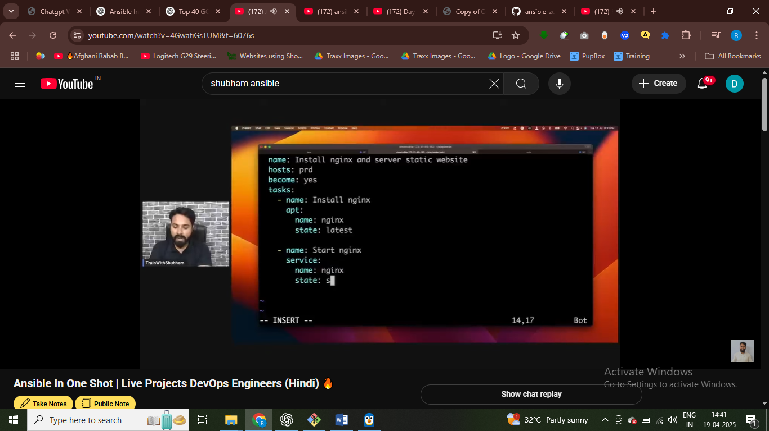

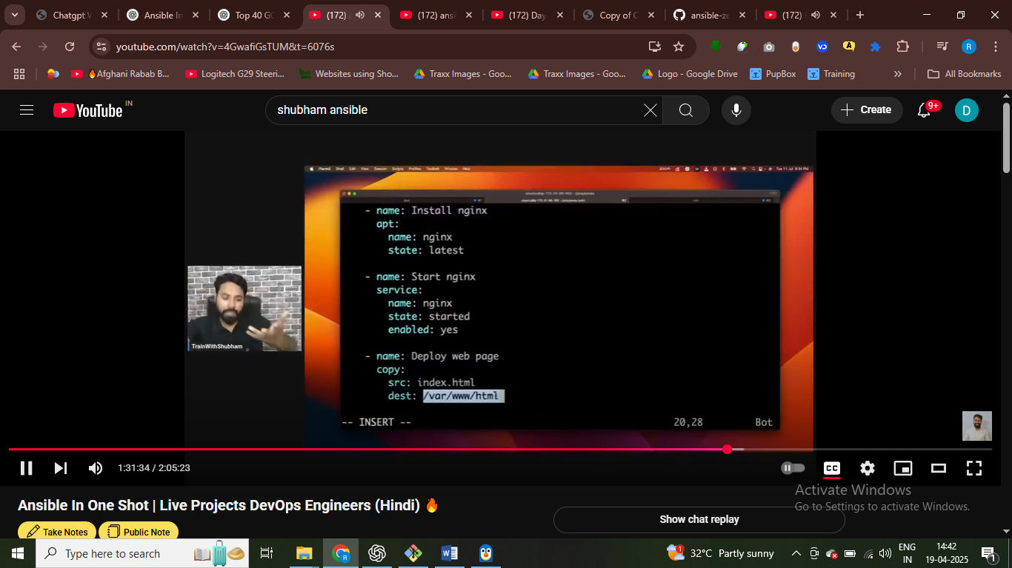

Souce index.html file we have - we need to cpopy file to dest inside nginx where our application server

Inside nginx

/var/www/nginx/html – in this our static webpage is goingn to serve

